History of Hampton Court Palace

Significant dates and people in the history of the palace

Palace timeline

1494 | Giles Daubeney, later Lord Chamberlain, leases and modernises the medieval manor of Hampton Court.
1515 | A year after leasing Hampton Court, Thomas Wolsey begins rebuilding on a grand scale, converting Hampton Court into a lavish palace.
1523 | Henry VIII’s former tutor John Skelton writes that, ‘The King’s court should hath the excellence. But Hampton Court hath the pre-eminence’.
1529 | Henry VIII’s royal workmen taken over building works at Hampton Court Palace.
1530 | Henry VIII and his councillors send the first letter threatening a break with the Papacy to Rome from the palace.
1537 | Queen Jane Seymour, Henry VIII’s third wife, gives birth to Prince Edward. He is baptized with great ceremony in the Chapel Royal, but she dies soon after due to complications from childbirth.
1540 | Henry VIII’s divorce from Anne of Cleves is signed at the palace. It is also where Henry VIII marries his fifth wife, Catherine Howard, and she is proclaimed queen.
1541 | Catherine Howard’s earlier sexual liaisons are revealed to Hendy VIII at Hampton Court. She is interrogated and kept under house arrest in the palace.
1543 | Henry VIII marries his sixth and final wife, Kateryn Parr, in the Chapel Royal.
1603 | Shakespeare and his company the ‘King’s Men’ perform plays in the Great Hall for King James I.
1604 | James I calls the Hampton Court Conference which commissions the King James Bible.
1689 | Sir Christopher Wren demolishes large parts of the Tudor palace and begins building a new place for King William III and Queen Mary II.
1760 | George III becomes king. He abandons Hampton Court as a royal residence and it begins to be divided up into grace-and-favour apartments.
1838 | Queen Victoria opens the gardens and state apartments to the public free of charge.
1944 | General, later President, Eisenhower plans the Normandy landings in Bushy Park.
1984 | Prince Charles, speaking at Hampton Court, calls for ‘a new harmony between imagination and taste and in the relationship between the architects and the people of the country’.

Palace People

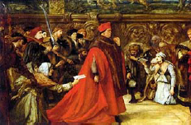  Cardinal Thomas Wolsey  Born c1475, died 1530  Lord Chancellor  Builder of Hampton Court |  | Thomas Wolsey was a priest from relatively humble beginnings, who was blessed with academic brilliance and rapacious ambition. It’s a matter of option which of these was more responsible for his rise to become Henry’s first minister, and chief political confidant, but once he’d got to the top, he has a lot to offer. He was perhaps the finest ministerial mind England had ever had until at least the 19th century.  He collected ecclesiastical titles and properties like stamps. He went from being a royal chaplain to Bishop of Lincoln, then Archbishop of York, finally Lord Chancellor of England. He also became Cardinal Wolsey, Papal Legate, whose authority in some respects therefore went beyond that of King Henry VIII himself.  Wolsey leased Hampton Court in 1514 and began building work a year later. He carried on making improvements throughout the 1520s. Descriptions record rich tapestry-lined apartments, and how you had to traverse eight rooms before finding his audience chamber. He was accused, after his death, of imagining himself the equal of sovereigns, and his fall from power a natural consequence of arrogance and overarching ambition.  Yet Wolsey was also a diligent statesman, who worked hard to translate Henry VIII’s own dreams and ambitions into effective domestic and foreign policy. When he failed to do so, most notably when Henry’s plans to divorce Katherine of Aragon were thwarted by Katherine herself and the Pope, his fall from favour was swift and final.  Thomas Wolsey died at Leicester Abbey in 1530, on his way to a possible final and fatal meeting with the royal wrath.
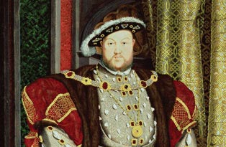  Kings Henry VIII  Born 1491, died 1547  Reigned: 1509-1447 |  | Henry VIII and his part in the history of Hampton Court Palace are momentous stories in the history of Britain.  For many people today, Hampton Court Palace is Henry VIII. It is indeed Henry’s royal standard that flies over the gatehouse. But it wasn’t always so. Early on in Henry VIII's reign, Thomas Wolsey, one of the chaplains in Henry's court, first acquired a relatively small manor house here in 1514, and constructed a magnificent palace around it.  Henry was married to Katherine of Aragon for almost 24 years. They shared a similar education and a love for court entertainment and learning. But, somewhere between the private tragedy of miscarriages and stillbirths and the public political and dynastic ambitions of Henry VIII, their marriage failed.  When Henry VIII wanted a divorce from Katherine, Cardinal Wolsey, in his unique position as papal legate and chief minister, was in a fantastic position to pull it off. Or fail.  Katherine resisted, and the Pope refused. Wolsey was helpless. His titles and properties were confiscated and the Cardinal died in 1530, after his arrest for treason. When Wolsey fell from power and influence Henry acquired Hampton Court, and began his own ostentatious building programme.  Hampton Court now truly became Henry VIII’s favourite palace. He spent more time here than at any other of his residences during the second half of his reign, building new apartments for himself and his new wives. And the palace survived to witness many of the most important events in the chequered political and matrimonial history of the 1530s and 1540s.
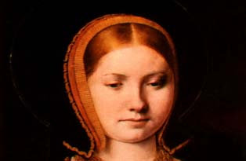  Katherine of Aragon  Born 1485, died 1536  First wife and queen to Henry VIII |  | Katherine was sent to England by her parents, Ferdinand of Aragon and Isabella of Castile, to marry the heir to the English throne, Prince Arthur. Accounts of the little fifteen-year-old princess describe her as ‘fair-coloured’ with a neat, regular oval face, and thick reddish-gold hair. ‘There is nothing wanting in her that the most beautiful girl should have’, wrote Thomas More.  She was pious, well-educated and politically aware. Even when Prince Arthur died, a few short months after their marriage, she remained in England, committed to her English destiny, and eventually married Arthur’s younger brother, Henry, when she was 23. Katherine and Henry VIII remained married for 24 years.  It was Katherine’s tragedy that, despite many pregnancies, only one of her children, Princess Mary, survived. As she reached 40, Katherine began to turn increasingly to religion - ‘Why had God not granted her a son?’ – as Henry began to look elsewhere for a solution to his dynastic quest. But, when Henry asked for an annulment to their marriage, Katherine summoned up every drop of pride and determination to protect her status as English queen.  She failed. Henry got his divorce – eventually – and married again. Katherine, separated from her daughter, and exiled from court, died, probably from cancer, aged 49.
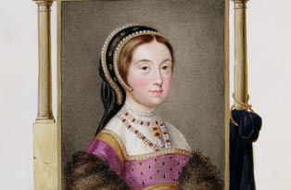  Catherine Howard  Born 1485, died 1536  Fifth wife and queen to Henry VIII |  | Accused of adultery  On 2 November 1541, Henry VIII arrived to celebrate mass in the Holy Day Closet at Hampton Court. Waiting for him was a letter from the Archbishop of Canterbury, Thomas Cranmer. This letter told Henry the alarming and intimate news that his young wife, Catherine, had been accused of adultery.  A sinful past and a questionable present  Henry was reluctant to believe Cranmer’s report, that his young and virtuous wife could have been unfaithful. Truth was, however, that rumours about Catherine’s less than innocent qualities had circulated since her marriage to the King earlier in the year. Catherine’s past apparently included an adolescent dalliance with her music teacher and her present a queue of flirtatious and ambitious courtiers.  Henry left Hampton Court and the interrogations to find out the truth began. Confessions from past lovers soon emerged and Catherine was confined to her lodgings at the palace. At first, she denied everything, but then confessed to her past, while insisting that she had been a dutiful wife since her marriage.  Eventually it emerged that Catherine had - at the very least - held illicit nocturnal meetings with a junior member of the King’s Privy Chamber called Thomas Culpepper. What actually went on behind Catherine’s bedroom door was never proved: but the intent to commit adultery and to deceive the King was enough.  The end for Henry’s fifth queen  On 13 November, Sir Thomas Wriothesley, one of the King’s principal secretaries, summoned Catherine’s household to the ‘Great Chamber’ at Hampton Court. This may have been the Great Watching Chamber which still survives today.  All were dismissed, and the Queen herself ordered out of the palace to house arrest at nearby Syon. She left the next day. Her jewellery that she had left behind at Hampton Court was inventoried: never a good indication of future prospects.  Culpepper and another confessed lover of Catherine, Francis Dereham, were executed in December. Catherine herself had only one journey left to make.  Leaving Syon for the Tower of London on 7 February 1542, Catherine faced five more days of bleak imprisonment before, at dawn on 13 February, like Anne Boleyn before her, she was beheaded. Catherine was 20 years old.
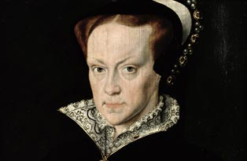  Queen Mary I  Born 1516, died 1558  Reigned: 1553-8 |  | Remembered as ‘Bloody Mary’, the Roman Catholic queen who attempted to reverse the Reformation and return England to Catholicism: around 300 men and women lost their lives for their faith.  Mary I at the palaces  Mary and her Spanish husband, King Philip II, took their honeymoon at Hampton Court Palace in 1554. Mary returned the following year, believing she was pregnant, but no child was born and the couple remained childless until Mary’s death in 1558.  Mary imprisoned her half-sister Elizabeth (later Elizabeth I) at the Tower of London in 1554. She suspected her of involvement in a plot against her, led by the traitor Sir Thomas Wyatt.  It soon became clear that there was not enough evidence against Elizabeth, and she was released into house arrest in the country.  Though known as ‘Bloody Mary’, historians have frequently claimed that Mary I was no more naturally malevolent than her half-siblings Edward VI and Elizabeth I, but as Protestants, English history has been kinder to them.  Certainly, executions for heresy or treason were a common feature of Tudor England. Henry VIII and Elizabeth I sent men and women to the Tower of London for no other reason than for their religious beliefs. Many others were executed.
King James I  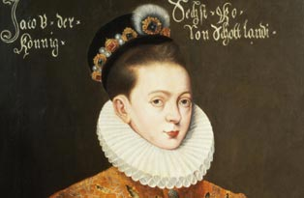  Born 1566, died 1625  Reigned as King of England: 1603-25 |  | Guy Fawkes and his co-conspirators in the Gunpowder Plot failed in their famous attempt to blow up the King and Parliament.  James I at Hampton Court Palace  In December 1603, the English aristocracy gathered at Hampton Court Palace for a fortnight of festivities: everyone was keen to get a glimpse of the new king as he hosted his first English winter court.  Behind the scenes, four Puritan ministers were summoned to appear, to make their case for further reform of the Church of England.  James was a Protestant monarch, but he also believed in the divine right of kings, and the Hampton Court Conference would witness a three-day debate to determine the direction the Church would follow under the Stuart dynasty.  James was a ‘walking library’ who wrote lengthy books on the art of being king and presided over the Hampton Court Conference and the commissioning of the ‘King James Bible’.  James himself was pilloried for being vulgar and gained a reputation for fawning over young men in public, pampering his favourites with money and titles. The whispers about his private behaviour ripened accordingly: he was not only accused of being decadent, but of being decadent without style.  His son Charles I would bring many glorious artworks to Hampton Court palace.
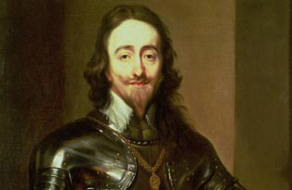  King Charles I  Born 1600, died 1649  Reigned: 1625-49 |  | The king was gallant and brave, but his wife Queen Henrietta Maria would sometimes countermand her husband’s military orders!  Charles I at the palaces  Charles I loved art and brought the world-famous Triumphs of Caesar by Andrea Mantegna to Hampton Court Palace.  Charles I used to have tremendous rows with his wife, the French princess Henrietta Maria, at Hampton Court Palace. She thought that France was better than England and that as a French princess she was more important than as an English queen.
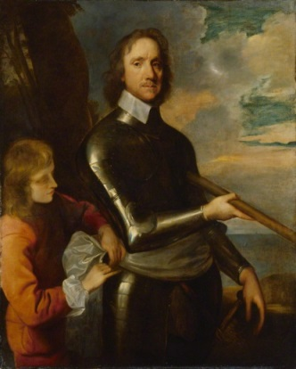  Oliver Cromwell  Born 1599, died 1658  Lord Protector of England: 1653-8 |  | Cromwell emerged as the Lord Protector of England after leading the Parliamentarian side to victory. Although he’d fought to get rid of the Stuart kings, he ended up being rather like a king himself.  Cromwell at Hampton Court Palace  As Lord Protector, Oliver Cromwell moved into Hampton Court Palace where he used the former queen’s bedroom for himself. He travelled down from London to spend quiet weekends here.  He enjoyed looking at Charles I’s art collection, and also had several beautiful statues moved into the Privy Garden. One of these was the lovely statue of Diana that ended up in the middle of the Round Pond in Bushy Park.  In 1660 Charles II was invited back to England to become King.

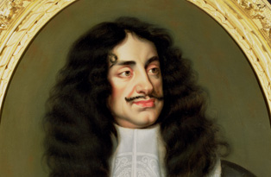  Kings Charles II  Born 1630, died 1685  Reigned: 1660–85 |  | He was invited to come back to England after years spent wandering round Europe to sit on his father’s throne in 1660. The country had had enough of the disruption caused by not having a king.  Charles II at Hampton Court Palace  Charles II installed one of his retired mistresses, Barbara Villiers, as Keeper and Chief Steward of the Mansion and Honour of Hampton Court Palace. He also spent his honeymoon with his official wife, Katherine of Braganza, at the palace.  Charles II made wig-wearing fashionable in London. The most popular ones were long, dark and curly, like the King’s own natural hair.  Although he recognised no fewer than 14 illegitimate children as his own, he never had a legitimate son or daughter to inherit his kingdom. His catholic brother reigned for three years before being removed from power and replaced with Protestants William III and Mary II.
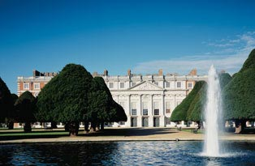  William and Mary  Reigned: 1689–1702  Builders of a new palace at Hampton Court |  | Soon after their accession to the English throne, King William III (r 1689-1702) and Queen Mary II (r 1689-94) commissioned Sir Christopher Wren to rebuild Hampton Court.  William liked both the pleasant site and the good hunting at Hampton Court, but thought the buildings needed replacing. He decided to go ahead with improvement work, because he didn't care for the monarch's principal residence at Whitehall Palace, and needed a substitute.  Grand designs  Wren's original plan was to demolish the entire Tudor palace, except for the Great Hall. Neither the time nor the money proved available for this ambitious undertaking. Wren had to be content with rebuilding the king's and queen's main apartments on the south and east sides of the palace, on the site of the old Tudor lodgings.  Work began in May 1689. William wanted rapid results, but in December, because of the excessive speed of building and the poor quality of the mortar used, a large section of the south range collapsed, killing two workmen and injuring eleven.  The subsequent inquiry deteriorated into bitter squabbles. It soon became apparent that the real cause was the speed of the work.  When building was resumed, it proceeded with less haste and more care. Between April 1689 and March 1694, £113,000 was spent on the new apartments.  A bit late, but under budget  William was devastated in late 1694 when Mary died. Work stopped, leaving the new buildings as an empty brick shell with bare walls and floors.  No further construction was undertaken until 1697. William’s European wars had ended by then, and he could once more devote his thoughts and money to palace building.  As Whitehall Palace burned down in 1698, William stepped up his efforts to finish the new palace. Instead of accepting Wren’s estimate for finishing the work, however, the king appointed Wren’s deputy. William Talman, who had offered a lower price, eventually finished William’s new King’s Apartments under budget
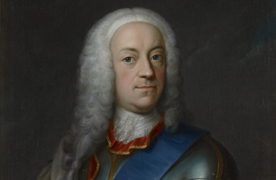  Kings George II  Born 1683, died 1760  Reigned: 1727-60 |  | George II made Kensington Palace the centre of his court life  George II fell out with both his father and his son  He was the last monarch to lead his troops into battle in 1743 at the Battle of Dettingen  George II at the palaces  As Prince of Wales, George felt that he was unfairly treated by his father – not given enough money and not entrusted with the regency when his father returned to Hanover. Relations between father and son were so sour that George and his wife Caroline were thrown out of court by George I and even, for a time, kept from their own children. In retaliation, they set up their own rival court filled with opposition politicians.  History was doomed to repeat itself. After George became King in 1727 (Handel’s Zadok the Priest was composed for his Coronation), George and Caroline’s glamorous son, Prince Frederick, arrived in England and in turn became embroiled in a battle of wills with his parents; he was eventually banished from court in 1737.  In the first ten years of George II’s reign, Kensington Palace was the glittering centre of court life where politicians, intellectuals and fashionable people vied for favour. George and Caroline used Hampton Court Palace regularly after their accession in 1727, especially during the summer when the palace would be alive with the flirtations, scheming and bickering of courtiers.

Henry VIII’s Six Wives

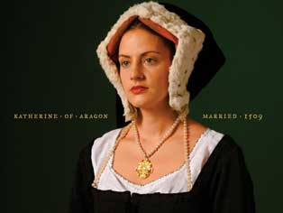  Katherine of Aragon |  | - The first of Henry VIII's six wives, Katherine of Aragon (1485-1536) was a Spanish princess who was married to Henry for 18 years before he began divorce proceedings in his desperation to re-marry and produce a male heir.  - Katherine had been pregnant six times but only one daughter, Princess Mary, later Mary I, had survived. Dying in 1536, Katherine wrote to Henry: 'Lastly, I make this vow, that mine eyes desire you above all things. Farewell.'
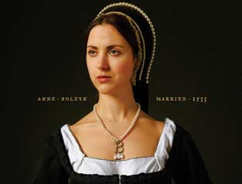  Anne Boleyn |  | - The second of Henry VIII's six wives, Anne Boleyn (c1501-36) was married to the King for only three years from 1533-6.  - Instead of the sought after male heir, Anne was pregnant with another princess, Elizabeth (later Elizabeth I).  - Anne was supported by religious reformers but was also hated by many at court. After a miscarriage, her fate was sealed and she was arrested (and later executed at the Tower of London) for adultery and incest.
Jane Seymour  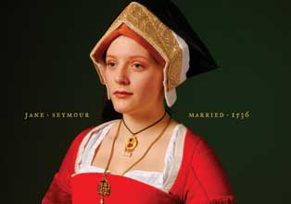 |  | - Jane Seymour (c1509-37) was the third of Henry VIII's six wives and the only wife to provide the King with the much longed for son and male heir.  - Having married Henry in May 1536, she gave birth to Prince Edward (later Edward VI) at Hampton Court Palace in 1537 but died soon afterwards.  - Henry had his son but grieved: 'Providence has mingled my joy with the bitterness of the death of her who brought me this happiness.'
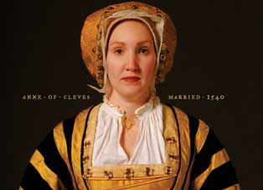  Anne of Cleves |  | - Anne of Cleves (1515-1557) was the fourth of Henry VIII's six wives and at 24 was half Henry's age when they married in January 1540.  - Henry first saw Anne of Cleves in a painting by Hans Holbein but in the flesh, Henry found Anne unattractive and began pursuing one of her maids of honour, Catherine Howard.  - After six months the marriage was annulled yet Anne remained in England and on good terms with Henry VIII. He commanded that she be treated as 'the king's sister'.
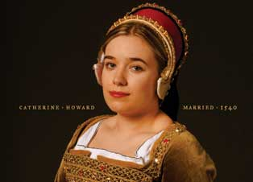  Catherine Howard |  | - Henry VIII's fifth wife was an alluring teenager named Catherine Howard (c1522-1542).  - They married only three weeks after his second divorce.  - After less than two years of marriage, rumours of Catherine's past and present love affairs reached a furious Henry.  - She was arrested at Hampton Court Palace and later taken to the Tower of London where she was beheaded in February 1542, aged about 21.
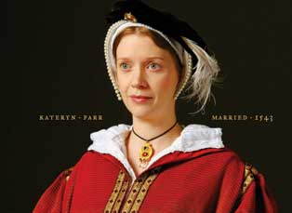  Keteryn Parr |  | - Kateryn Parr (1512-48) was the last of Henry VIII's six wives.  - Intelligent and devout, Kateryn loved Thomas Seymour but Henry's proposal could not be refused. She and Henry VIII married at Hampton Court Palace in July 1543. He was 52, she was 31.  - After the King's death in 1547, Kateryn was free to marry Seymour but she died 15 months later, aged 36, having given birth to their daughter.

