Tower of London

Key Characters

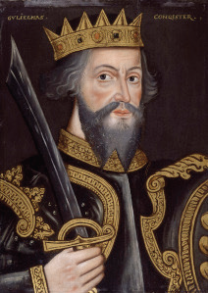  William the Conqueror  (c.1028 – c.1087) |  | William Duke of Normandy became the first Norman king of England when he defeated Harold Godwinson’s army at the Battle of Hastings in 1066.  The first years of William’s reign were spent crushing resistance and securing his kingdom to make certain that his new subjects were in no doubt who was in control. To do this he started a programme of castle building which would last the rest of his life.  William knew that the key to controlling England was to control London. He needed to find an effective way of securing the capital and defending himself against the city’s ‘hostile inhabitants’.  Led by Bishop Gundulf, work began in 1078 to replace one of London’s existing wooden fortresses with a new stone castle which would dominate the skyline and be large enough to act as a royal palace, military garrison and administrative centre for the kingdom.  After 30 years the Tower was finished complete with battlements that soared more than 90 feet in the air dwarfing the primitive wooden dwellings that surrounded it.
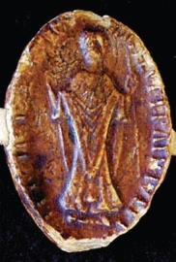  Ranulf Flambard  (c.1060 – 1128) |  | Ranulf Flambard was probably the first state prisoner confined to the Tower, and also the first to escape from it!  As financial administrator to William II, Flambard was a powerful and influential man, acting as regent in the king’s absence. William was an unpopular King notorious for levying large taxes to finance his campaigns abroad.  When William was killed in battle his younger brother Henry claimed the throne. Eager to prove popular with his new subjects, Henry had the unpopular Flambard arrested and imprisoned in the White Tower.  After six months of imprisonment, Flambard began to hatch a plan for his escape. He proposed to throw an elaborate banquet for his guards and requested that several barrels of wine be provided for the occasion. Within one of these barrels was a length of rope. The wine was plentiful and very soon the guards became intoxicated, enabling Flambard to make his escape out of the window, down the rope and onto a waiting boat. From here he travelled to Normandy.
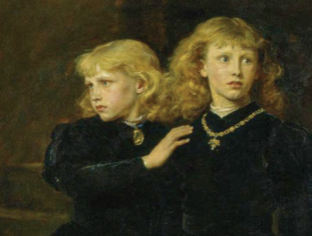  Princes in the Tower  (Edward 1470 – 1483, Richard 1473 - 1483) |  | The princes in the Tower were Edward and Richard, the sons of Edward IV and Elizabeth Woodville.  Edward IV had come to the throne after defeating the Lancastrians in the Wars of the Roses. When he died suddenly in 1483, his son Edward was proclaimed king in his place.  As a 12 year-old, he was not old enough to rule as king, so his father chose his own brother, Richard, Duke of Gloucester to be the Lord Protector until Edward was old enough to rule on his own.  Edward was rushed to London by his uncle Lord Rivers, as Rivers wanted to become Lord Protector himself. However they were caught by Richard, Duke of York, who escorted his nephew to the Tower of London where he was lodged along with his brother. With the new king safely incarcerated Richard mounted a campaign to prove that the boys were in fact illegitimate and declared himself king.  The princes were last seen alive in June 1483 and it is widely believed that their uncle had them murdered. Support for this claim was unearthed in 1674 when the bodies of two children were discovered during building works at the Tower.
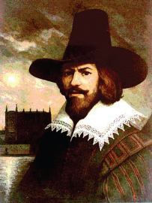  Guy Fawkes  (1570 - 1606) |  | Guy Fawkes was described by his contemporaries as ‘a man highly skilled in matters of war’. He was also a master of deceit, a characteristic which landed him a key role in the conspiracy known today as the Gunpowder Plot.  During a campaign fighting for Spain in Flanders, Fawkes was approached by Thomas Wintour who revealed plans for a rebellion which would see Catholicism restored to England. The plan was to ignite a stock of gunpowder in the vaults beneath the House of Lords whilst the King’s Council was in session. Because of his expertise with gunpowder, it would be Fawkes who would be responsible for igniting the touchpaper.  On 4th November 1605, after 18 months of planning, Fawkes awaited his cue beneath the House of Lords. Posing as John Johnson, Fawkes twice diverted officials who had been tipped off that something was afoot. Eventually he was searched and, along with the 35 barrels of gunpowder discovered in the vaults, officials found matches, and touchpaper on his person.  Guy was escorted to Whitehall to confront James I in person and then to the Tower where he was subjected to various tortures before confessing and being sentenced to a traitor’s death.
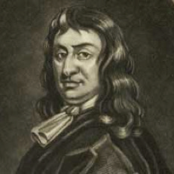  Colonel Blood  (1618 - 1680) |  | To this day Thomas Blood remains one of England’s most notorious and celebrated jewel thieves.  Born in Ireland, Blood came to England in 1642 to fight for Cromwell’s army during the Civil War. After the Restoration of the monarchy in 1660, Blood became involved in a number of republican plots before sinking into the murky depths of London’s criminal underworld.  In a display of grandeur befitting the restored monarchy, the new king, had a new set of crown jewels commissioned and put on display in the Martin Tower at the Tower of London. For reasons still unknown, Blood hatched a plot to steal these jewels by grooming the jewel keeper and his family over a period of months before attacking him and attempting to smuggle the jewels out beneath his cloak. As he prepared to flee from the scene, the Jewel Keepers son raised the alarm and Blood was arrested.  This attempt to steal the jewels led to a comprehensive review of security at the Tower.
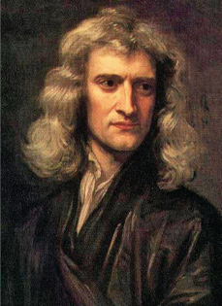  Isaac Newton  (1646 - 1727) |  | Isaac Newton was an English physicist and mathematician, and the greatest scientist of his era.  Best known for his works on the composition of light and theory of gravity, in 1696 Isaac Newton was appointed Warden of the Mint, which was then based at the Tower of London.  Newton took his job in the Mint seriously. He calculated the most efficient method to produce coins, and his observations helped the Mint re-coin nearly £2.5 million of silver in three years.  Part of Newton’s job was also to track down counterfeiters who made fake coins. The punishment for coin counterfeiting was death, and Newton didn’t hesitate to send many criminals to prison and the hangman’s noose for their crimes.  In 1699, Isaac Newton was promoted to Master of the Mint, a post he held until his death in 1727.
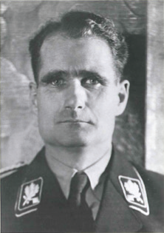  Rudolf Hess  (1894 - 1987) |  | Hess was the son of a wealthy German merchant and a devoted follower of Adolf Hitler.  In 1941 Hess made a solo flight from Bavaria to Scotland where he crash landed. He was arrested and taken to the Tower.  After four days of interrogation Hess was sent to spend the remainder of the war at Mychett Place in Surrey before being sentenced to life imprisonment at the Nuremberg Trials of 1946.  Why Hess came to England is as much of a mystery as how he died. Rudolph Hess became one of the last state prisoners to be held at the Tower.
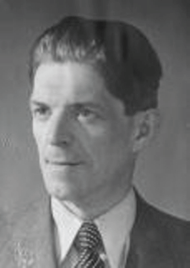  Josef Jakobs  (1838 - 1941) |  | By the 20th century the Tower served primarily as a museum. One role that it did retain was that of an enduring symbol of the monarchy and British Empire – standing defiant in the face of Nazi onslaught.  It was for this reason, in August 1941, that Josef Jakobs became the last person to be executed at the Tower.  Six months earlier Jakobs had been discovered on farmland lying beneath a camouflage parachute. He protested his innocence but it was soon discovered he carried a number of incriminating items, including a wireless transmitter, false papers and maps of nearby RAF bases.  At a court martial Jakobs was found guilty of espionage and lodged overnight in the east turret room of the Waterloo Block before being executed by a firing squad. The chair used for his execution can be found in the Royal Armouries’ collection.
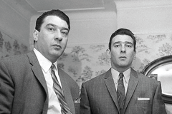  Ronnie and Reggie Kray  (Ronnie 1933 – 1995, Reggie 1933 – 2000) |  | Ronnie and Reggie Kray were English gangsters who became the foremost perpetrators of organised crime in the East end of London during the 1950s and 1960s.  As young men in 1952, the brothers were called up for National Service with the Royal Fusiliers. After failing to report they were arrested and turned over to the army who held them at the Tower.  This seemingly minor incident led to a spell at a military prison in Somerset but this did not deter them.  Together with their gang ‘The Firm’ the twins went on to commit armed robberies, assaults and murders. Despite being much feared their cult status brought with it an element of celebrity.

