Applying History
Hampton Court Palace

Artefacts

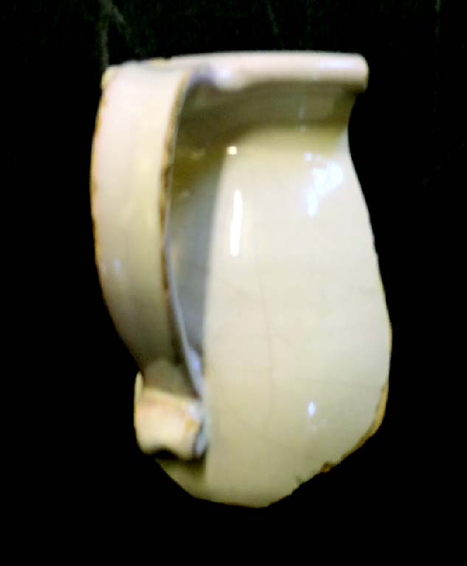  Chamber pot fragment  Date: c.1700  Found: Hampton Court moat excavation  Image: Image credit text  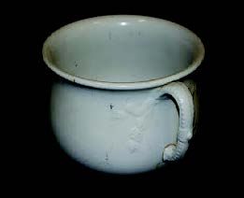  Complete chamber pot |  | This fragment of pottery is from a chamber pot. It is around 300 years old and was found in an archaeological excavation of the moat, just by the main entrance to Hampton Court Palace.  These objects were known as chamber pots because they were kept in the bedchamber – they were used during the night to avoid walking outside to the toilet. Only the very rich and influential had a private room for their toilet but, before flushing systems were invented, even the Georgian Kings used a chamber pot; enclosed within a seat called a stool. The ‘Groom of the Stool’ had the job of emptying the King’s chamber pot, but he also washed the King and shared in his confidences so held great power within the Court.  This particular chamber pot is more humble. It has no decoration and is rather small. It was probably made in London, and its white glaze, inside and out, would have made it waterproof and easily cleaned.
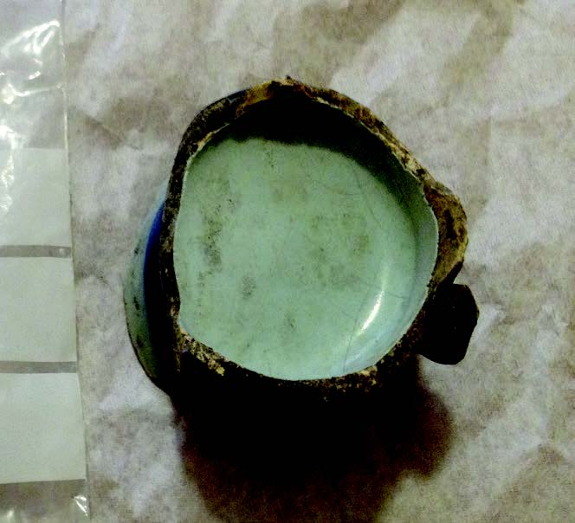  Chocolate cup base  Date: 1650 – 1750  Found: Hampton Court moat excavation  Image: Image credit text |  | This is the base of a small cup that was designed specifically for drinking hot chocolate. It dates from the late 17th to early 18th century when drinking chocolate was extremely fashionable and exclusive. The curvaceous yet refined shape of the cup reflected this sensuous new drink.  Blue and white pottery like this was made in London from the late 16th century in imitation of the more expensive Delftware from the Netherlands. The cup was wheel-thrown, with a delicately applied handle. Before firing in the kiln, the pottery was covered in a lead glaze; made opaque white by the addition of tin oxide. The blue pattern comes from cobalt which looks black when it’s painted on, but changes to blue when it’s fired.  This fragment was found in 1910 in the excavation of the moat at Hampton Court Palace. It was almost certainly used c.300 years ago in the Chocolate Kitchen in Fountain Court, and it recently acted as the reference for replicas that we had made to furnish the re-presented kitchen.
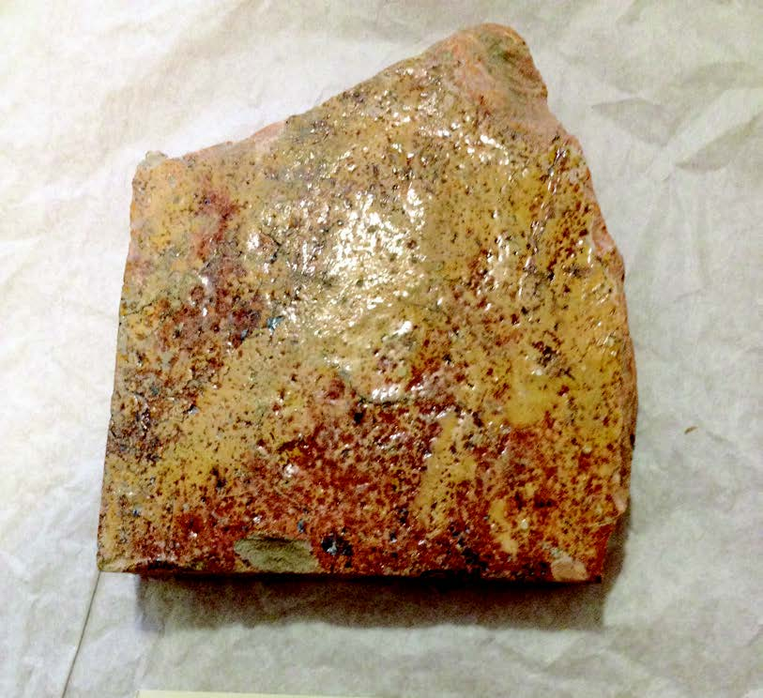  Glazed tile  Date: 1517 - 1534  Found: Hampton Court kitchens  Image: Image credit text  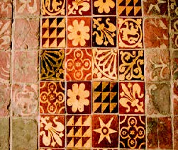  A richly decorated Tudor tile floor  Image: Image credit text |  | This glazed floor tile comes from between the Great Hall and the Tudor Kitchens at Hampton Court Palace. It is made of ceramic, with a glaze to make it hard wearing and washable. The floor would have seen very heavy footfall and probably a lot of spillage as food was carried to the Great Hall.  Hampton Court Palace led the way in Tudor fashion with its brightly coloured décor. Not just the furnishings, but the Palace itself was multi-coloured, with brick walls painted red, and exposed timbers in yellow, red, green and white. If you look closely at the glaze on this tile you can see that the clear glaze directly onto ceramic results in a dark brown colour, but a thin white layer has been added between the surface of the tile and the glaze. This is ‘slip’ – a very runny white clay that has been painted on, so that when it is fired, the tile comes out bright yellow.  Look again and you might see that the surface of the tile has been scratched and worn. This is from members of the Royal Court, nearly 500 years ago, walking backwards and forwards from the Kitchens to the Great Hall. It would have been more heavily worn, but we know that this tile was only exposed for a short period – it was laid as part of Cardinal Wolsey’s Palace in c.1517, but when Henry VIII remodelled this area in 1534, it became buried under his new floor.
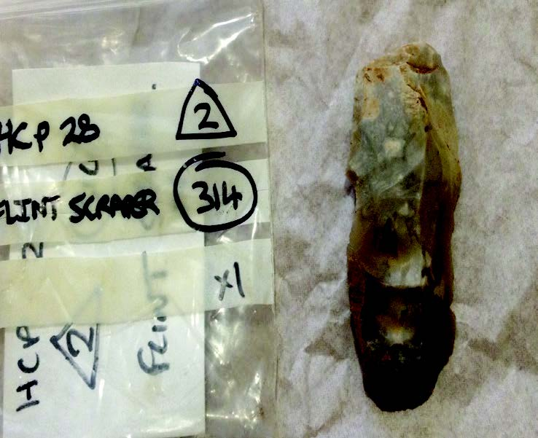  Flint tool  Date: c.3,000 – 2,000 BC  Found: Privy Garden excavation  Image: Image credit text |  | This is an end scraper; a prehistoric flint tool. It is quite a rough example and probably dates from c. 3,000 – 2,000 BC; the Late Neolithic to Early Bronze Age, when flint technology was starting to decline from its height in the Mesolithic to Early Neolithic. This ‘stone age’ technology was quite sophisticated. Flakes of stone were knapped (chipped) from larger pieces of flint and then worked into tools which could be shaper than a modern razor. This end scraper has been chipped along its front edge to give a curved serrated blade, ideal for attaching to a wooden handle and using to remove animal flesh from skin – essential for preparing food and clothes.  This tool was found in the privy garden to the south of Hampton Court Palace. When it was made, the land would have looked totally different. The Thames was a network of shallow channels with numerous islands, and humans were starting to clear the dense natural woodland to enable farming for the first time. The land here was ideal for settlement; fertile, well-drained, and with important access to the river for drinking water, fishing and transport. In fact, a Bronze Age wooden boat was found preserved in the Thames at Hampton Court - close to where this tool was probably used c.4,500 years ago.
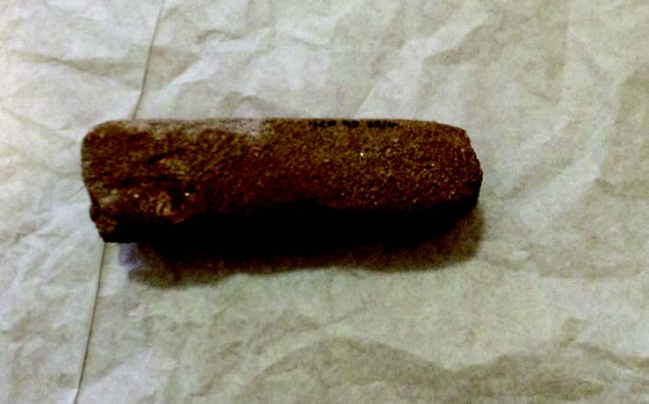  Whetstone  Date: 1700s  Found: Privy Garden excavation  Image: Image credit text |  | This stone has been worn down into a square cross section for use as a whetstone. It is made of old red sandstone; rough enough to scour a blade down, and resilient enough to not wear out quickly. Whetstones are generally thought of as for sharpening knives, and Hampton Court must have used many in the kitchens.  This stone, however, was found with two more in the Privy Garden, and is bigger than a standard whetstone. We think that this was for use by the gardeners for sharpening their shears, scythes etc. and generally attending to the 18th century garden.  If you hold the stone in your left hand as if ready to sharpen a blade, you will find there is a diagonally worn stripe across the stone. This shows the original gardener to have been right handed and gives a real feel of how the object was used.
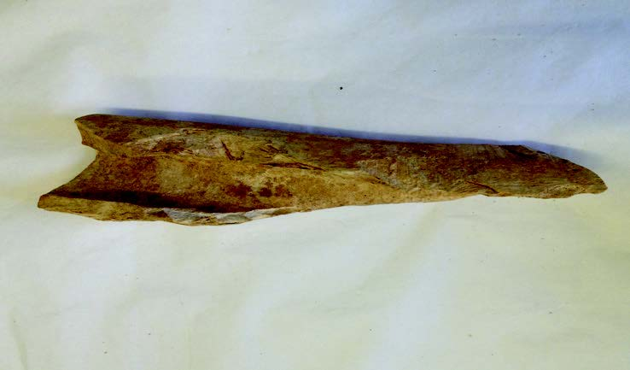  Butchered animal bone  Date: Before 1517  Found: Great Hall excavations  Image: Image credit text |  | This is a butchered long bone from a large mammal, probably a cow. It was found in 1974 beneath the Great Hall in a series of excavations that revealed the layout of the hall before it was rebuilt by Henry VIII. We therefore know it is more than 500 years old. It has survived so well because of the alkaline conditions created by the chalk foundations of the Great Hall.  The long bone has many cut marks from having been butchered. Some of these would have been to remove meat from the bone, but it has also been cut in half. This is to reach the marrow in the centre of the bone which was very nutritious, tasty and a part of Tudor cookery. The meat from this bone would have been served in the Great Hall above, where all the 600 members of Court were fed twice a day. The annual provision of meat for the Tudor court stood at 1,240 oxen, 8,200 sheep, 2,330 deer, 760 calves, 1,870 pigs and 53 wild boar.
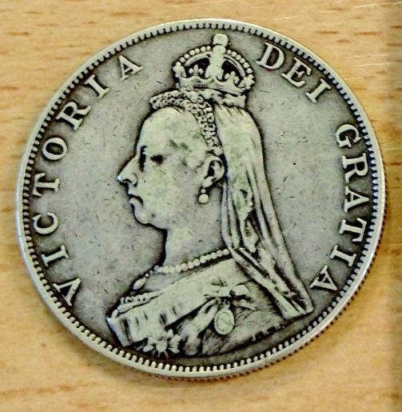  Coin  Date: 1887  Found: Tower Hill mint  Image: Image credit text |  | This coin was made near the Tower of London at the Tower Hill Mint. It was worth 4 shillings (48p) and called a double florin. When it was made, this coin would have bought you what £40 buys in today’s money.  Hampton Court Palace opened free to the public in 1838 during Victoria’s reign and it boomed as a tourist attraction with buses every 20 minutes and a new railway built to transport visitors from central London.  This coin was made at the time of Victoria’s golden jubilee in 1887 celebrating her 50 years on the throne.  In 1861, Prince Albert, Victoria beloved husband died at a tragically young age of Typhoid fever. For the rest of her life Victoria wore mourning clothes which included dark colours and no brightly coloured jewels.  The small crown she wears on this coin was made so she could look formal but still dress in mourning, as it contains no coloured stones. The crown now forms part of the Crown Jewels in the Tower of London.
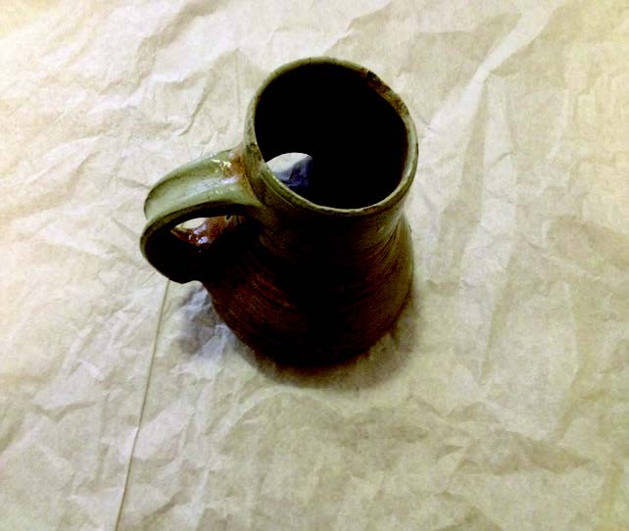  Beer mug  Date: c1480-1550  Found: Hampton Court excavation  Image: Image credit text  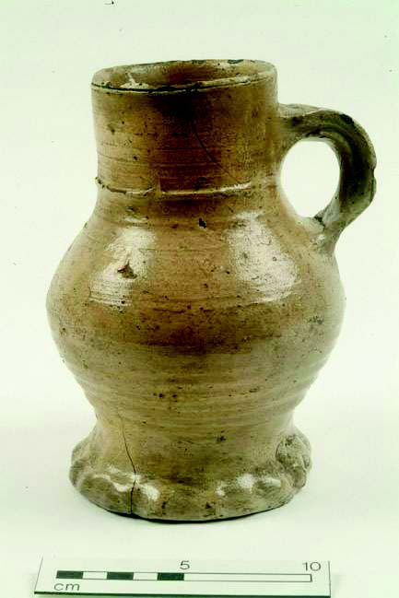  A raeren mug  Image courtesy of Museum of London |  | This is a 500-year-old beer mug. It was found in Hampton Court in an archaeological excavation, but it was made close to the border of Belgium and Germany in an area called Raeren.  Raeren was famous for this type of pottery from the late 15th to 16th century, and it exported huge quantities of it across Europe. The mug was made on a potter’s wheel and it has a very characteristic shape. You can still see the potter’s thumb mark where he fixed the handle to the body of the pot. It is made of stoneware which has been fired to such a heat that it becomes waterproof.
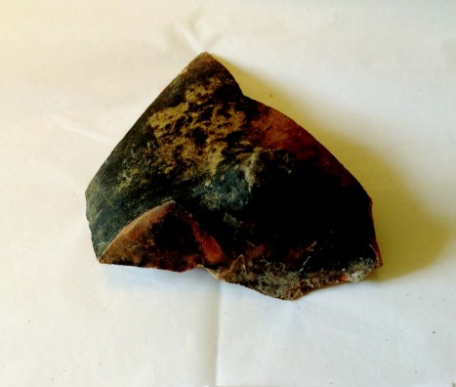  Tripod pipkin  Date: 1600s  Found: Hampton Court excavation  Image: Image credit text  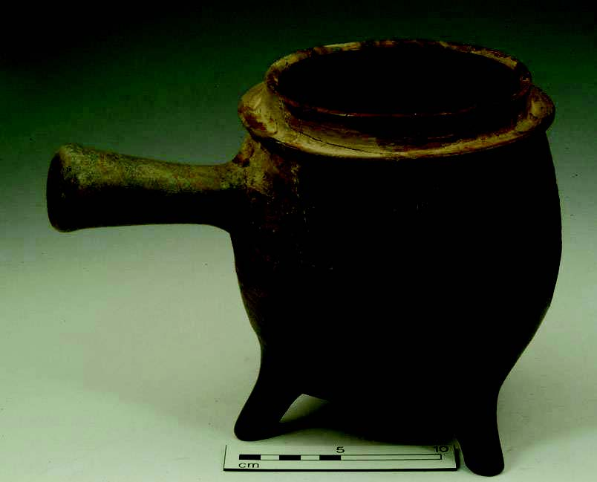  A complete tripod pipkin  Image: Image credit text |  | This is a cooking vessel from the 17th century. It had three feet and was designed to stand in a fireplace for slow-cooking dishes such as stew. This could be a small cauldron (without a handle) or a large tripod pipkin, but it was found at Hampton Court where cooking was done on a grand scale. The inside is glazed to be waterproof, and the soot on the outside shows that it has been used in an open fire. Pipkins had a lid to keep  the moisture in, and a single hollow handle, a bit like a modern saucepan. If you look closely you can see the fingerprints of the potter as he attached one of the feet to the base of the pot.
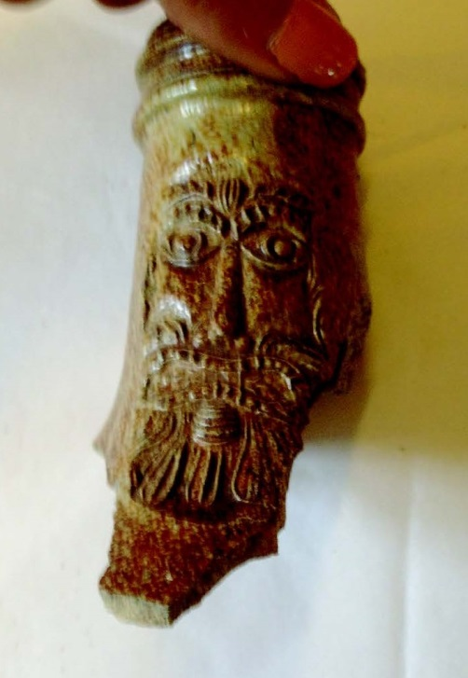  Bellarmine jar fragment  Date: 1550 - 1700  Found: Hampton Court moat excavation  Image: Image credit text  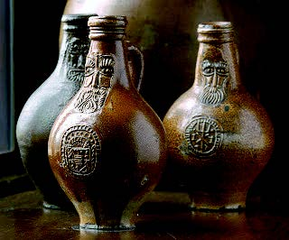  Examples of complete bartman jugs  Image: Image credit text |  | This is the top of a Bartman jug - made in Germany in the 16th – 17th century, and found in 1910 in the moat at Hampton Court. Our name for them is a corruption of the German name ‘Baardman’, or beard man, obviously due to the bearded face on the front. People thought the bearded face looked like Cardinal Bellarmine (who confronted Galileo in the early 17th century over the theory that the earth turned around the sun), so they are often called ‘Bellarmine’ jugs.  Bartman jugs were for storing and drinking wine and beer. They are made of a type of pottery called stoneware which has been fired so hot (1200-1400°C) that the minerals fuse together, making the pottery waterproof and suitable for storing liquids. England imported huge quantities of German stoneware, especially Bartman jugs, until the mid-17th century when we developed our own stoneware industry and, more importantly, developed glass bottles as an alternative.  The speckled surface is from a salt glaze. At the end of the firing, salt was thrown into the kiln which instantly vapourised and fused with the surface of the pottery. Chlorine gas was given off; a poisonous gas that was later used as chemical weapon in the First World War.
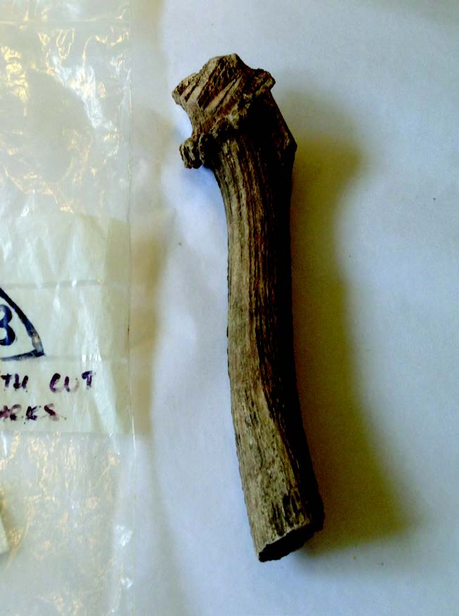  Red deer antler  Date: Unknown  Found: Privy Garden excavation  Image: Image credit text |  | This is the base of an antler from a red deer; the flared part once attached to the skull. Only the males have antlers, which they use for courtship display and fighting. Their antlers grow each year, and Tudor huntsmen would have hoped to catch a hart (a stag which is more than 5 years old), or even a ‘hart of ten’ - a stag with ten points on its antlers.  Hunting was a popular Tudor sport, with Henry VIII and Elizabeth I both being keen hunters. Home Park, the wide parkland that stretches out from Hampton Court Palace, was enclosed as a deer park in c.1515, and a long wall was built through the middle of it to direct the chase - this was known as the deer course.  Red and fallow deer have been kept in Home Park since Tudor times, although the hunt was considered as sport, it did also supply the Court with venison. This antler was found in excavations of the Privy Garden at Hampton Court, and is thought to be waste from food preparation in the kitchen.
Tudor brick  Date: c.1530 - 1565  Found: Privy Garden excavation  Image: Image credit text  Decorative use of different coloured bricks to form a diamond or diaper pattern.  Image: Image credit text |  | This is a Tudor brick that was found in an archaeological excavation of the Privy Garden at Hampton Court Palace. It dates from the time of Henry VIII, but was found as a piece of rubble in an 18th century garden. The mortar on the brick indicates that it has been laid in a wall and that it came from a demolished Tudor building. There were several buildings dating from the time of Henry VIII that were demolished to make way for the Baroque Palace and its garden, including a large gateway onto the River Thames that was located not far from this brick was found.  We know this is Tudor because of its dimensions, the type of clay that it is made from, and the technique that was used to make it. One side of the brick is darker and more purple in colour from where it was closer to the heat in the kiln; later bricks would have been fired more evenly. In Tudor times, however, they used this colour variation decoratively, by making a chequered pattern called ‘diaper work’ with the dark bricks. American diapers get their name from the same pattern – the checked cloth that used to be used for nappies.  Bricks are made of a mixture of clay and sand, and the ground at Hampton Court has just the right balance of these materials for making bricks. We have written records that bricks were dug and fired in the grounds of the Palace, and in 2014 we actually found the remains of two Tudor brick kilns in the park.
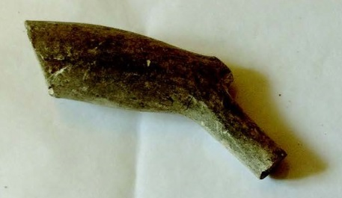  Clay pipe  Date: c.1530 - 1565  Found: Privy Garden excavation  Image: Image credit text  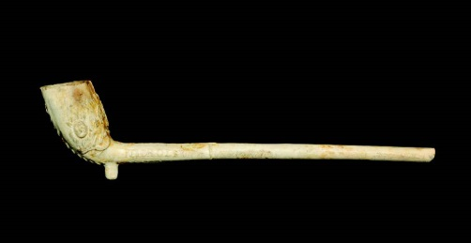  An example of a complete clay pipe with a decorated bowl,  Image: Image credit text |  | This is a clay pipe, used for smoking tobacco more than 300 years ago. Clay pipes were first made in Elizabethan England after the introduction of tobacco. At first, tobacco was extremely rare and expensive, so the pipes were very small, but as imports increased, the pipes got bigger. Their design was also very susceptible to changing fashions, so we can work out when they date from quite accurately from their size and shape. This pipe dates from 1680-1710.  Although this pipe was manufactured in London, it was made from a particular kind of white clay, kaolin, that was mined in Cornwall and brought to London by boat. Pipes were formed in moulds and fired in small kilns.  Unfortunately we no longer have a record of where this pipe was found. It comes from Hampton Court, from the time of William and Mary’s remodelling of the Palace, but without a context there is little value in the object. It is a very important principle of archaeology that the accurate location of a find must always be recorded.
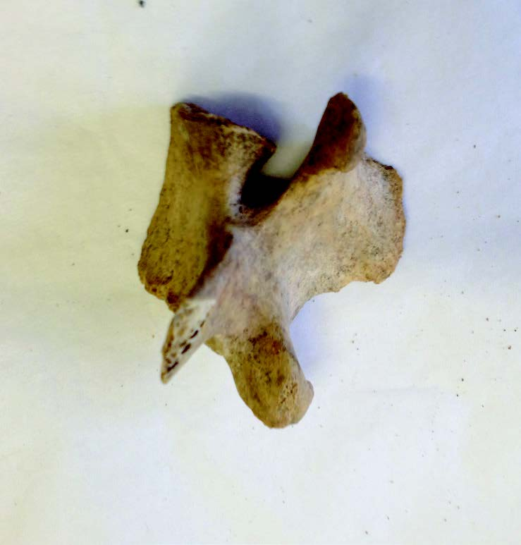  Animal vertebra  Date: Unknown  Found: Hampton Court  Image: Image credit text |  | This is half a vertebra (one of the back bones) of a sheep or goat. You can see that it has been sliced clean in half with a very sharp meat cleaver; one of the first stages of butchering a carcass for food.  Unfortunately we no longer have a record of where this bone was found. It comes from Hampton Court, but without a context there is little value in the object and we don’t know how old it is. It is a very important principle of archaeology that the accurate location of a find must always be recorded.
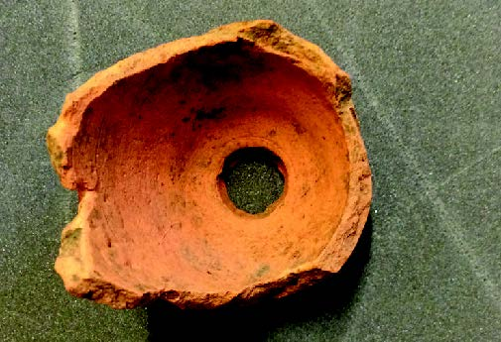  Flower pot  Date: 1800 – 1900s  Found: Privy Garden excavation  Image: Image credit text |  | This is the base of a ceramic flower pot. It was found in 1993 as part of the archaeological excavation of the Privy Gardens at Hampton Court. It looks very familiar, but the base (with its thick curving sides) shows that it is not a modern form. Many flower pots have been recovered from the gardens at Hampton Court, and the more we find, the more we are able to work out the development of the different styles and how old they might be. We think this dates from the early 19th century.
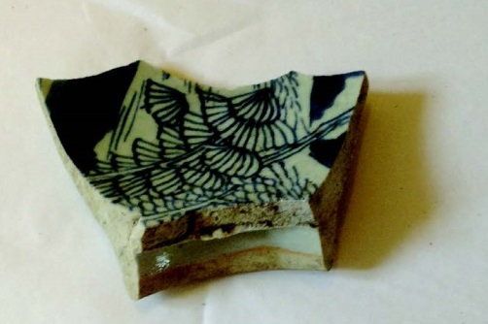  Chinese porcelain  Date: 1600s  Found: Hampton Court  Image: Image credit text |  | This is a piece of porcelain, imported from China in the 17th century. It is a robust piece from a large bowl, with decoration of pine trees in blue. China had long held the technology for producing superior ceramics. Europe tried copying the look of their pottery with blue and white wares like Delft, but they did not have the immensely hard and waterproof properties of Chinese porcelain.  For this reason, Chinese imports were very valuable, and it is no surprise that they would be found, as this was, in the Royal Palace of Hampton Court. This piece might well have been collected by Queen Mary II, or one of her courtiers, before it was broken and unceremoniously thrown away in the moat.

Archaeological symbols

Type | Description | Written
Site number | A number given to each excavation so we can trace where an artefact was found. | HCP 35
Context number | The layer in which an object was found.
Small find number | A small find is an artefact which was thought to be significant enough to be given its own number. Artefacts found in large numbers are stored together under one number as a ‘bulk’ find.

