School resource

Symbols of Power

Key Characters

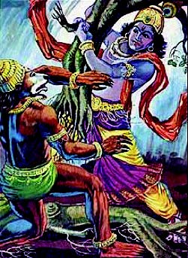  Krishna and Jambavan |  | According to some Hindu legends, the Koh-i-Nûr diamond was found over 5000 years ago and given to Krishna by Jambavan, King of the Bears.  The jewel was originally a gift from the sun god Surya to a loyal follower but was later stolen and found its way into the hands of Jambavan, an immortal hero who could transform himself into a bear.  Krishna, a supreme god, was accused of stealing the jewel and vowed to track down the real thief to prove his innocence. Eventually his search lead him to Jambavan and after 28 days of fighting, Jambavan returned the diamond to Krishna along with his daughter’s hand in marriage.  Later a curse was put on the jewel: ‘He who owns this diamond shall own the world, but will also know all of its misfortunes. Only god, or a woman, can wear it with impunity.’
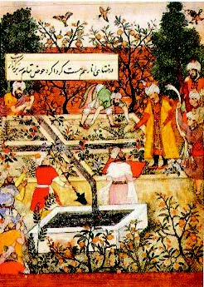  Emperor Babur  1483 - 1530 |  | In 1526 Babur defeated Ibrahim Shah Lodi, the last of the Delhi sultans to become the founder of the Mughal Empire.  Babur was both a military genius and a great writer, leaving behind his memoirs in which we find one of the first historical references to the Koh-i-Nûr. According to Babur, the diamond was part of the treasure won by Al-ud-deen (Aladdin) at the conquest of Malwah in 1304 AD.  After Babur’s death the diamond was subsequently handed down the succession of Mughal emperors including his son, who was first to fall foul of the diamond’s curse by being driven from his kingdom into exile. In 1719 Emperor Muhammad Shah became the last of the Mughal emperors to possess the Koh-i-Nûr.
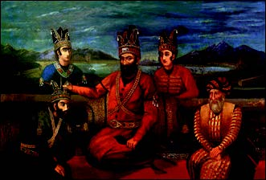  Nadir Shah  1688 - 1747 |  | After recapturing the lost Persian territories from the hands of the Russians and restoring the Persian Empire, general Nadir Shah set his sights on the Indian subcontinent.  In 1739 he invaded and plundered Delhi, ransacking the city and gathering together all of the wealth and jewels that he could find to take back to Iran.  As Nadir Shah was preparing to return home he realised that the Koh-i-Nûr diamond was not among the loot. Legend has it that the general was tipped off that his enemy kept the diamond hidden in his turban. Later, at a banquet held to display their friendship, Nadir suggested that the Emperor partake in an age-old custom in which the leaders would exchange their turbans. To refuse this offer would have been a great insult and so the Emperor reluctantly obliged. As the gem fell to the ground and caught the light, Nadir Shah is said to have exclaimed ‘Koh-i-Nûr’ (meaning Mountain of Light). The diamond has been known by this name ever since.  Nadir Shah was later assassinated by his own troops and the diamond passed to one of his Afghan commanders Ahmed Khan Abdali.
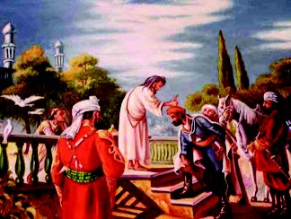  Ahmad Abdali  1722 - 1772 |  | After returning home to his country, the Afghan chief Ahmad Abdali embarked on a series of conquests, profiting from the weakened state of neighbouring countries.  In a few years Ahmad had extended the Durani Empire to such an extent that it became the second largest Muslim Empire in the world. Today he is considered the founder of the modern state of Afghanistan.  Throughout his reign Ahmad Abdali held onto the Koh-i-Nur diamond as a symbol of his authority.
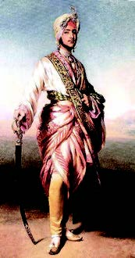  Maharaja Ranjit Singh  1780 – 1839  Duleep Singh  1838 - 1893 |  | Maharajah Ranjit Singh allegedly seized the Koh-i-Nûr from Shah Shuja, an exiled Afghan King, in return for his sanctuary.  When Ranjit (also known as the Lion of Lahore) died in 1839 the Punjab kingdom passed to his five year old son Duleep.  Several years later the Sikh empire was seized by the British and divided into four provinces: Lahore, Multan, Peshawar and Kashmir.  One of the terms of the Treaty of Lahore, the legal agreement that formalised the occupation, was that ‘the gem called the Koh-i-Nûr which was taken from Shah Shuja by Maharajah Ranjit Singh shall be surrendered by the Maharajah of Lahore to the Queen of England’. The diamond’s passage to Britain was a carefully choreographed exercise. In 1851 Duleep Singh travelled to England to present Queen Victoria with the diamond in an official ceremony.  Prince Duleep was made a ward of the British Crown, complete with an annual stipend of £50,000. Over time he became a loyal and devoted subject of the Queen’s and she developed a strong attachment to him.  Duleep died in Paris in 1893 after suffering for many years from mental and physical illness.
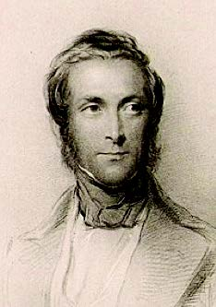  Lord Dalhousie, Governor General of India  1812 - 1860 |  | In 1847, Lord Dalhousie became the youngest Governor General of India.  During his tenure Dalhousie is credited with masterminding the subjugation of the Punjab, conquering and annexing large territories, expanding the Indian road, rail and canal systems and appropriating a great many Indian assets for the use of the East India Trading Company.  His acquisition of the Koh-i-Nûr diamond was criticized by many of his contemporaries who believed that it should have been presented to Queen Victoria as a gift. Dalhousie, however, felt strongly that the stone was a spoil of war and should be treated accordingly. He was responsible for masterminding the delivery of the diamond to the Queen and determined that it should be a spectacle. In a letter to a friend in 1849 he wrote: ‘My motive was simply this: That it was more for the honour of the Queen that the Koh-i-Nûr should be surrendered directly from the hand of the conquered prince into the hands of the sovereign who was his conqueror, than it should be presented as a gift’.  Despite his numerous successes, many of Dalhousie’s policies caused resentment and have since been cited as having contributed to the Indian Mutiny of 1857.
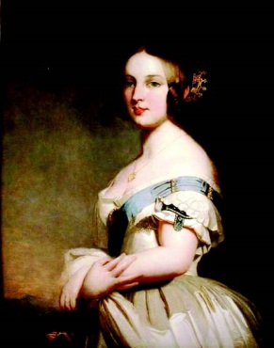  Queen Victoria  1819 - 1901 |  | Queen Victoria was the longest reigning British monarch and the figurehead of a vast Empire.  She was very interested in India and even spent some time studying the Indian language of Hindustani, under the teaching of one of her servants.  After the Indian mutiny of 1857 the government of India was transferred from the East India Company to the Crown.  In 1877, Benjamin Disraeli, Conservative Prime Minister, had Queen Victoria proclaimed Empress of India. Whilst India was already under crown control, this title was a gesture to link the monarchy with the empire and bind India more closely to Britain.  I  n her later years, Queen Victoria made no secret of her dislike for flaunting the Koh-i-Nûr as a symbol of Indian subjugation of Britain.

