School resource

Symbols of Power

Classroom activities

Stage a Debate: Should the Koh-i-Nûr be returned to India?

Divide the class into 2 groups (Yes and No). Using the sources in the booklet, each group will have to consider and represent the view of their side. For the debate: One person from each side can present their side’s argument. The debate structure can follow the order of the points in the source booklets. There should be counter-arguments from each side and a closing statement, before their peers can contribute with further arguments

Dramatise the story of the Koh-i-Nûr

“The story of the Koh-i-Nûr is the history of India.” Research the journey of the Koh-i-Nûr from the Mughal Emperors to the British Empire. Put together a short dramatisation of the story of the Koh-i-Nûr.

The return of the Koh-i-Nûr

Divide the class into 4 groups each representing officials from the countries who once had possession of the Koh-i-Nûr (Mughals, Afghans, Sikhs, British). Select 4 impartial individuals to act as a panel who will decide who deserves to have the diamond returned to them. Each group must research their country’s claim to the stone and present an argument as to why it should be returned to them.

Duleep Singh

Investigate the life of Duleep Singh and his family – did you know that his youngest daughter, Princess Sophia played an active part in the suffragette movement? None of his children had any offspring, and with them ended his line and any claim to the Sikh kingdom.

The Tower as a Jewel House

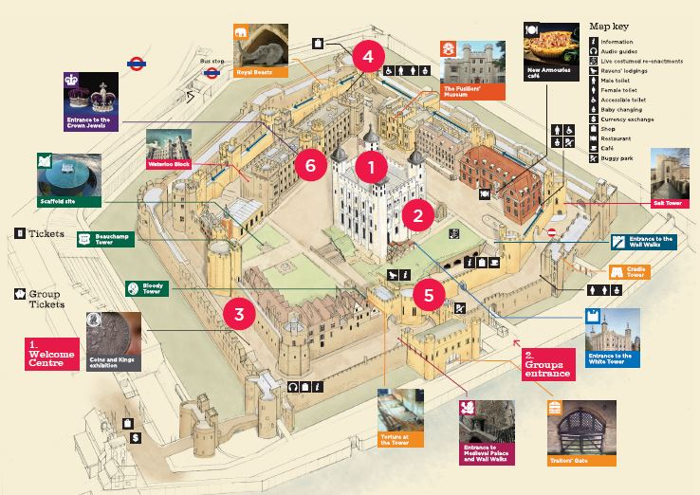

    - Since the 1100s the Tower has been a stronghold for the nation’s valuables including the personal jewels of the monarch, most of which were stored in the White Tower.

    - In 1508 Henry VII had a repository built for the jewels on the South Side of the Tower. This remained in place until 1649.

    - Following the Civil War all crowns and other symbols of monarchy were marked for destruction, melted down and made into coins at the Mint.

    - When the monarchy was restored in 1658, a new set of crown jewels was made for Charles II’s coronation. The new collection was housed in the Martin Tower.

    - In 1671, the infamous ‘Colonel’ Thomas Blood almost succeeded in stealing the Crown Jewels. Despite a tightening of security visitors were still able to reach through the bars and touch the Crown Jewels until the 19th century when they were moved to the Wakefield Tower.

    - Finally in 1967 a new purpose built Jewel House was opened beneath the Waterloo Barracks.

