Learning & Engagement Volunteers at Tower of London
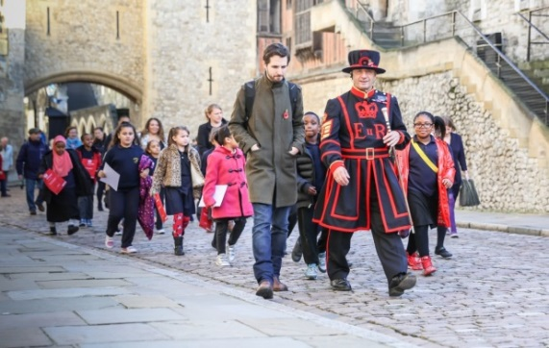
We are looking for enthusiastic and friendly people to support the Learning & Engagement team at the Tower of London. The Learning & Engagement team work with a range of audiences including primary and secondary pupils, GCSE and A Level students, families and adult learners and we’d like your help in welcoming these groups to our palaces.

Family Learning Volunteer role at HM Tower of London

Your role will be to support the Learning & Engagement team by offering a 5 star visitor service and by being an enthusiastic, warm and friendly face to all our family visitors. We run family learning activities during school holidays and your role will be to explain these activities, encourage participation and supervise the activity tables.

This role is based on the visitor route inside the Tower and will operate during school holidays between the hours of 10:30 am - 4:30 pm. Interviews will take place at HM Tower of London on Thursday, 11 January 2018 at 2 pm with a training date for successful applicants on Thursday, 25 January at 2:30 pm.

Skills and Qualities

For this role we are looking for volunteers who….
- enjoy working with children or families
- are confident and effective communicators
- can work well in a team
- have a love of history
- have an imaginative, approachable and friendly way of interacting with visitors
- are self-motivated and pro-active

Next Steps

We are flexible about how much time you can give us but you do need to be able to volunteer on a regular basis. Please contact Sarah Levine: Sarah.Levine@hrp.org.uk.

