Who killed the

Princes in the Tower?

Key Characters

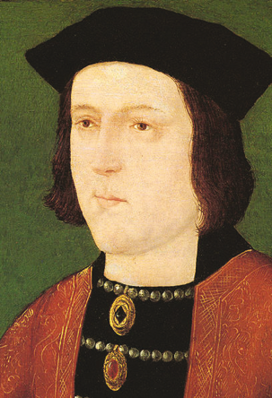  Edward IV  1442 - 1483  King (1st time): 1461–70 (2nd time): 1471–83 |  | Edward IV was born in troubled times during the Wars of the Roses, in which his family (the Yorkists) fought the Lancastrian family for control of England. He spent his early reign as king fighting battles across the country.  As a king he was expected to marry someone of equal social status. But instead of marrying a European princess, he married Elizabeth Woodville, one of his subjects, and not even from one of the leading families in the land! The marriage was scandalous and unpopular as the Woodville family used their connection to gain power.  The marriage continued to be a problem and in 1483 Dr Ralph Shaa preached that it was an illegal marriage as Edward IV had previously been engaged to someone else. This meant his sons were illegitimate and could not inherit the throne, which went to his brother Richard instead.  Edward IV died when his sons were still boys, and had told his brother Richard, Duke of Gloucester, that he wanted him to look after the country until young Edward was old enough to rule in his own right.
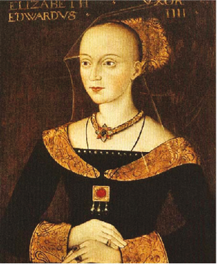  Elizabeth Woodville  Born about 1437,  died 1492 |  | Elizabeth Woodville was a beauty in her day, and she married Edward VI secretly in around 1461. The scandal of Edward’s secret marriage to a commoner outraged his supporters and created violence and chaos in England.  Edward and Elizabeth had many children, but the only boys were Edward and Richard, who became known as the ‘Princes in the Tower’ after their mysterious disappearance in 1483.  After Edward IV’s death, she tried to protect her sons and get Edward crowned as soon as possible, but her brother-in-law Richard, Duke of Gloucester managed to hold the boys in the Tower and delay young Edward’s coronation.  After her sons disappeared, Elizabeth married her eldest daughter to Henry Tudor, strengthening his claim to the throne, which he took after defeating Richard III in battle in 1485.

Princes

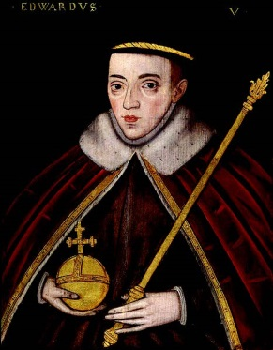  Edward V  Born 1470, last seen 1483, King 1483  And  Richard of Shrewsbury, Duke of York,  Born 1473, last seen 1483 |  | The two boys of Edward IV and Elizabeth Woodville were the heirs to the throne, with Edward, the eldest, becoming king after their father’s death.  As a 12 year-old, he was not old enough to rule as king, so his father chose his own brother, Richard, Duke of Gloucester to be the Lord Protector until Edward was old enough to rule on his own.  Edward and Richard were both used by different people who wanted to rule the country. Edward was rushed to London by his uncle Lord Rivers, as Rivers wanted to become Lord Protector.  However they were caught by Richard, Duke of York, who kept Edward in the Tower of London where he could not be used by the Woodvilles or anyone else who wanted power instead of Richard.  In 1674 some bones were found in the Tower of London, they were of some children, but we don’t know if they were boys or girls. These bones were thought to be the two princes, and are buried in Westminster Abbey, the traditional burial place of kings.
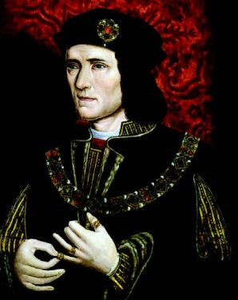  Richard III, Duke of Gloucester  Born 1452, died 1485,  King 1483-5 |  | There are few kings with such a bad reputation as Richard III. He was painted as a villainous ugly hunchback in William Shakespeare’s play about him. But was he really so bad? The Richard III society promotes a very different view of the king.  As a young man he fought in many battles in the Wars of the Roses for his family (the Yorkists). His brother Edward IV later trusted him to run the north of England. Edward also named him as Lord Protector for his young son.  After Edward IV’s death he worked to get young Edward and Richard in his care, and placed him in the Tower of London for safety. But for whose safety? Was it for the boys or for Richard himself?  It is the fate of the two princes, and Richard’s role in imprisoning the boys, taking the throne and their disappearance, that has coloured our view of him.  His reign did not last long and he was killed during the battle of Bosworth in 1485. He is still in the news today, as his bones were discovered in 2012, and people argue over where he should be buried.

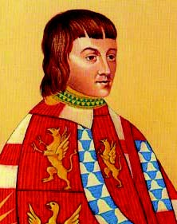  Anthony Woodville, Earl Rivers  Born around 1440, died 1483 |  | Earl Rivers was Elizabeth Woodville’s brother. At the time of Edward IV’s death he was in Wales with young Edward and immediately set off to bring the new king to London.  His actions were interpreted as treason by Richard, Duke of Gloucester, who feared Rivers wanted to take the important job of Lord Protector of the young king for himself.  Rivers was accused of treason, sent to prison in Pontefract in Yorkshire, and executed.
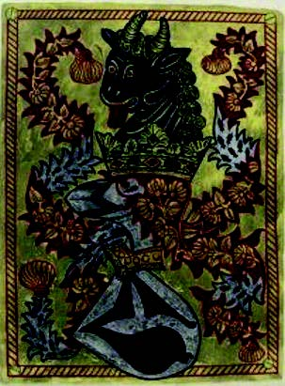  William Hastings, Baron (or Lord) Hastings  Born around 1431,  died 1483 |  | William Hastings was a close friend and advisor of Edward IV. After Edward’s death his position as a rich an influential man was in danger if he chose the wrong side. Hastings tried to stop the Woodville’s gaining too much power and helped Richard, Duke of York.  But things changed for the worse when Richard accused Hastings of plotting with the Woodvilles to kill him. During a council meeting at the Tower of London, Richard accused Hastings of treason and had him executed immediately and without trial.
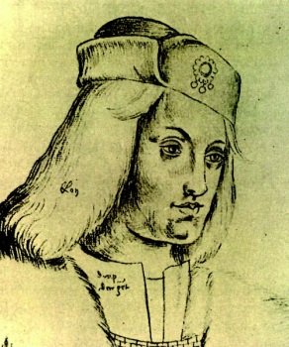  Perkin Warbeck  Born around 1474,  died 1499 |  | The problem with the disappearance of the Princes in the Tower, was that no one ever saw the boys’ dead bodies, and rumours went about that they were still alive.  In 1490 a young man showed up at a court in Europe claiming to be one of the princes: Richard, Duke of York. Edward IV’s sister Margaret of York recognised him and so proved his identity. When he landed in England in 1497 the new Tudor king Henry VII was worried that ‘Richard’ would try and take the throne.  After some time in the Tower, Perkin confessed to being an imposter and was released. But Henry VII kept a close eye on him, and when he tried to run away, Perkin was imprisoned again and then hanged.

