1066 and the

Norman Tower of London

Key Characters

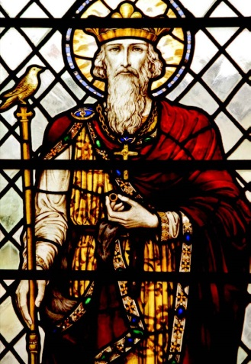  Edward the Confessor  (c. 1003-1066)  Reigned 1042-1066 |  | Edward was the penultimate Anglo-Saxon king of England.  He was the son of Æthelred II ‘ the Unready’ and spent much of his early life in exile in Normandy before becoming King in 1042.  Edwards’s Norman sympathies caused tension among his new subjects resulting in the crisis in 1050 when his father-in-law, Godwin of Wessex, assembled an army against him. Godwin and his sympathisers were banished and Norman barons were appointed at court in their place.  The last 15 years of Edward’s reign were relatively peaceful. Edward was not an extravagant king, nor was he a great military leader. This meant that taxes remained low and the country prospered.  Edwards was known as ‘the Confessor’ because he led a deeply religious life. One of his greatest legacies is Westminster Abbey, the foundations of which were laid during his reign.  He died childless on 4 January 1066 leaving several potential claimants vying for the throne.
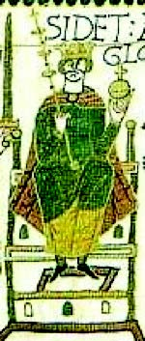  Harold Godwinson  (c. 1022-1066)  Reigned 1066 |  | Harold II (or Harold Godwinson) was the last Anglo-Saxon king of England.  In Anglo-Saxon times, there was no strict line of succession. When a king died, the male members of his family: sons, brothers, uncles, nephews, would all be eligible for the throne and the one with the most power and supporters became king.  Shortly before his death, Edward the Confessor named Harold as his successor, although his distant cousin William, Duke of Normandy, also had a claim to the throne. This began one of the most bitterly contested successions in history.  Legend has it that in 1064 Harold was shipwrecked off the coast of Normandy. William is believed to have captured him and forced him to swear an oath to support his claim.  When Edward died and Harold assumed power, William mounted a campaign to seize the throne. On 14 October 1066 William and Harold met in battle near Hastings where Harold was defeated and killed.

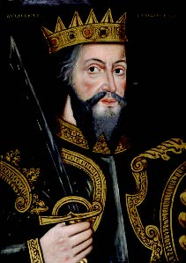  Duke William II of Normandy (William I of England)  (c. 1028-1087)  Reigned 1066-1087 |  | Also known as William the Conqueror, William the Bastard.  William I was the first Norman King of England. William was a very experienced and ruthless military commander, ruler and administrator who had unified Normandy and inspired fear and respect amongst his contemporaries.  In 1066 he defeated and killed the English king Harold Godwinson at the Battle of Hastings and was crowned king on Christmas Day at Westminster Abbey.  Even after he secured victory, William faced much opposition. His first task was to ‘pacify’ the land and control what William referred to as ‘the fickleness of the vast and furious population’. To make certain that his new subjects did not forget who controlled their country William began a programme of castle-building that would last for the rest of his life.  William knew that the key to controlling England was to control London and so he commissioned Bishop Gundulf to supervise works on a great new fortress that would dominate the town and be large enough to serve several functions: as a royal palace, a military garrison for his troops and an administrative centre for the kingdom.  The White Tower itself was probably not started until ten years after the Battle of Hastings. It took around 25 years to complete and William died long before it was finished.
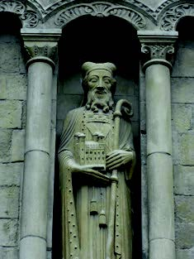  Bishop Gundulf  (d. 1108) |  | Gundulf was a Norman monk who came to England following the conquest.  Gundulf was a clerk with a reputation for architectural genius on the continent, having already designed numerous churches and military fortifications.  William I was aware of Gundulf’s architectural prowess and requested that he oversee the construction of his new fortress in London. At first Gundulf refused, saying that he wanted to see out his days building churches, not fortresses. Undeterred, William offered Gundulf an incentive – if he agreed to build this new castle, the king would give royal approval to the building of a new cathedral in Rochester, after which Gundulf would be made bishop of the same.  In 1077 Gundulf was appointed Bishop of Rochester and commissioned by William I to supervise ‘the kings great works on the great tower of London’.
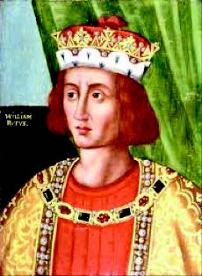  William III  (c. 1056-1100)  Reigned 1087-1100 |  | Also known as William Rufus.  At his death in 1087, William I divided his kingdom and possessions among his three sons: Richard, who acquired England, and Henry, who inherited 5,000 pounds of silver.  The manner in which William the Conqueror divided his possessions caused turmoil among his sons and many Norman barons found themselves caught up in the midst of a battle for succession.  Known as William Rufus because of his ruddy complexion, he was an unpopular king disliked for his lack of piety and his extravagant lifestyle funded by heavy taxes.  It fell to William II to complete his father’s great Tower and, in doing so, he helped to define its role as a great royal fortress.  He died after being struck by an arrow whilst hunting. Although supposedly an accident, it has been suggested that he was shot deliberately on the orders of his brother Henry.

