School Resource

(In)glorious revolution

Key characters

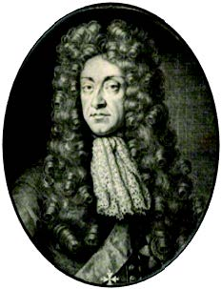  James II  Born 1633, died 1701  King 1685–88 |  | James II was the second son of Charles I, the monarch who was executed by his own people after years of civil wars in England and Scotland.  James grew up in exile in France and moved back to England when his brother Charles II was invited to take back the throne in 1685.  James was born a Protestant, but converted to Catholicism in the 1660s.  At first he kept it a secret because Catholics were feared and hated in  England, but during the 1670s and 1680s he worked to gain religious freedoms for Catholics.  His daughters, Mary and Anne, from his first marriage were brought up  Protestant. But he married the Catholic Mary of Modena in 1673 and when  their son James was born in 1688, people feared that England would stay  Catholic and looked to the Protestant William of Orange for help.  He fled England after the Glorious Revolution in 1688. He attempted to get back his throne, but was defeated in battle in the Battle of the Boyne in Ireland in 1690. He retired to France and died there in 1701, but his supporters, the Jacobites, continued to make trouble and try and put his heirs on the throne until 1746.
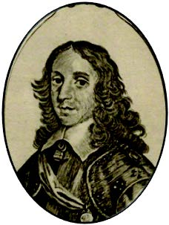  William of Orange  Born 1650, died 1702  King 1689–1702 |  | William was the son of one of Charles I’s daughters, meaning James II was his uncle, and his wife Mary, was also his cousin.  His marriage to his cousin Mary didn’t start well: she cried at the wedding.  But they grew to love each other very much.  As Stadtholder or ruler of the Netherlands, William took his job as Protestant ruler seriously, and fought the attempts of the French King Louis XIV to invade large areas of Europe and make them Catholic.  William saw the threat of James II as a Catholic king in England and made sure he was ‘invited’ to take the throne, jointly with his wife Mary. However, his powers as king were limited, as Parliament was wary of giving their new elected monarchs too much power.  William suffered from asthma and liked to stay at palaces far away from the smoke and dust of the city. However, his court disliked travelling to faraway places like Hampton Court and Kensington Palace.  When Mary died, William was devastated, and never remarried. In his later years he took to drinking in his private chambers at Hampton Court with close friends. He died from pneumonia after a nast y fall from a horse.
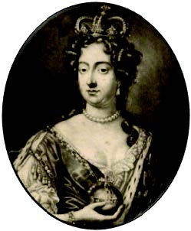  Mary Stuart  Born 1662, died 1694  Queen 1689–1694 |  | Mary was the eldest daughter of James II, but unlike her father, she remained a Protestant throughout her life.  She was married at only 15 years old to her older cousin William of Orange, and she cried throughout the wedding ceremony. She moved to the Netherlands and was popular with the Dutch people. She learned to love William dearly, and he loved her in return.  Until the birth of her half-brother to Mary of Modena, her father’s second wife, Mary had been next in line to the throne after James II. The birth of the new prince meant he was the heir to the throne, and a Catholic too.  William and Mary were joint monarchs, as Mary did not want to rule on her own, as William had plenty of experience from being the Dutch Stadtholder.  Mary died young aged only 32 of smallpox – a deadly disease that could strike rich or poor.
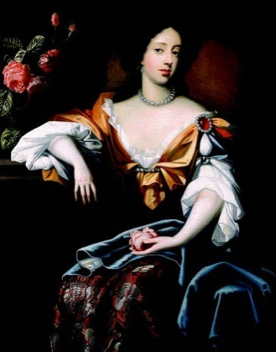  Mary of Modena  Born 1658, died 1718 |  | Mary was an Italian princess who became James II’s wife after his first wife, Anne Hyde, died. Mary was Catholic like her husband, and the birth of their first child, James Francis Edward sparked rumours and fears.  The birth of the prince meant he and not his older sister Mary Stuart was now next in line to the throne, and as he was to be brought up a Catholic, this worried many people.  There were also rumours that the real Prince James had died at birth and a new baby was smuggled into the Queen’s bedchamber in a warming pan (a kind of large lidded frying pan used to warm cold beds).  The rumour meant many people suspected the child was not the real heir to the throne.
James Francis Edward Stuart  Born 1688, died 1766 |  | James was the unfortunate son of James II and Mary of Modena. His birth upset many people who wanted his Protestant sister Mary to rule after their father’s death. Rumours about his birth spread and stayed with him. In later life he always claimed to be the true king of England and Scotland, and was recognised as such by the French king Louis XIV. However he spent his life in exile in Europe and never ruled in Britain, despite uprisings by his supporters who were called Jacobites.
The immortal seven |  | This is the name given to the seven noblemen who sent a letter to William of Orange to invite him to be king. The men were: the Earls of Danby, Shrewsbury, and Devonshire, Viscount Lumley, the Bishop of London, Edward Russell and Henry Sydney. Their invitation is the reason many believe the events of 1688-9 are often called the glorious revolution. Without an invite, would William of Orange have been seen as an invader rather than a saviour of the people?

