Hillsborough Castle and Gardens

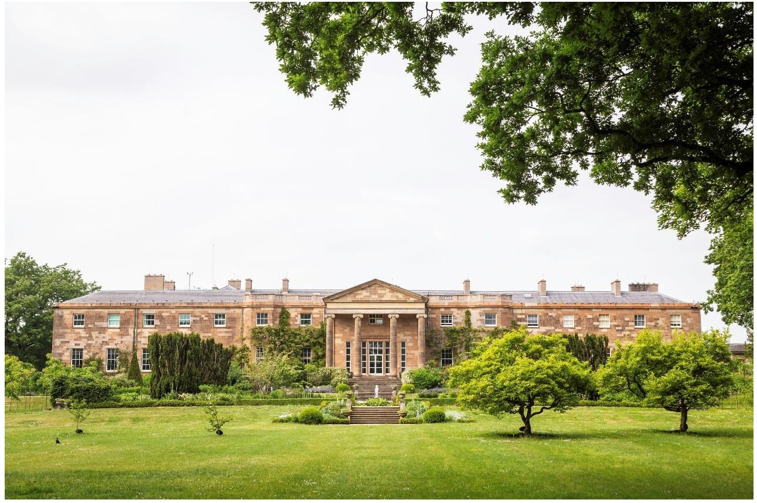

Visual Guide

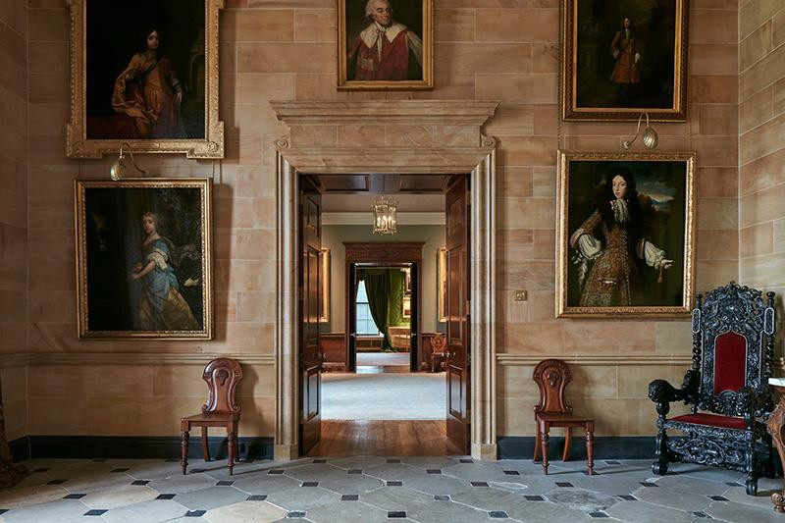
I am going to visit
Hillsborough Castle
and Gardens

I will explore, learn new things, and have fun!

We might get to Hillsborough Castle and Gardens by going in the car or bus

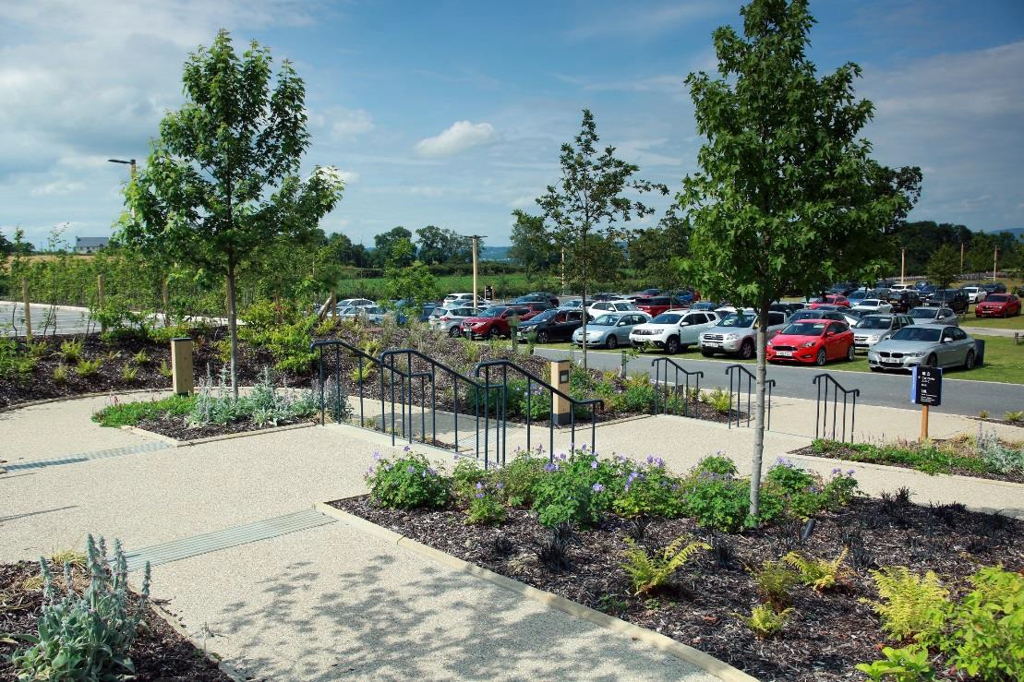We might arrive at the
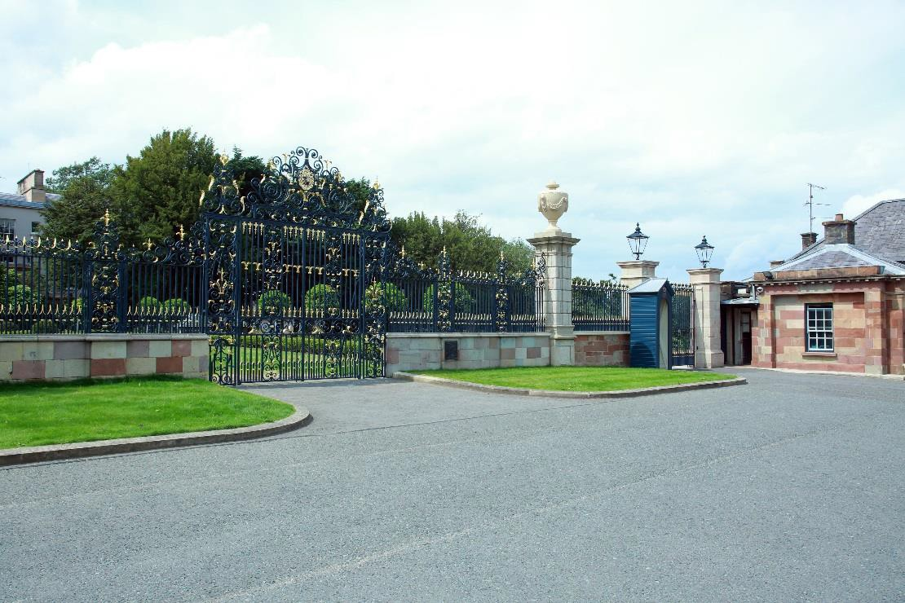lower site

or the upper site

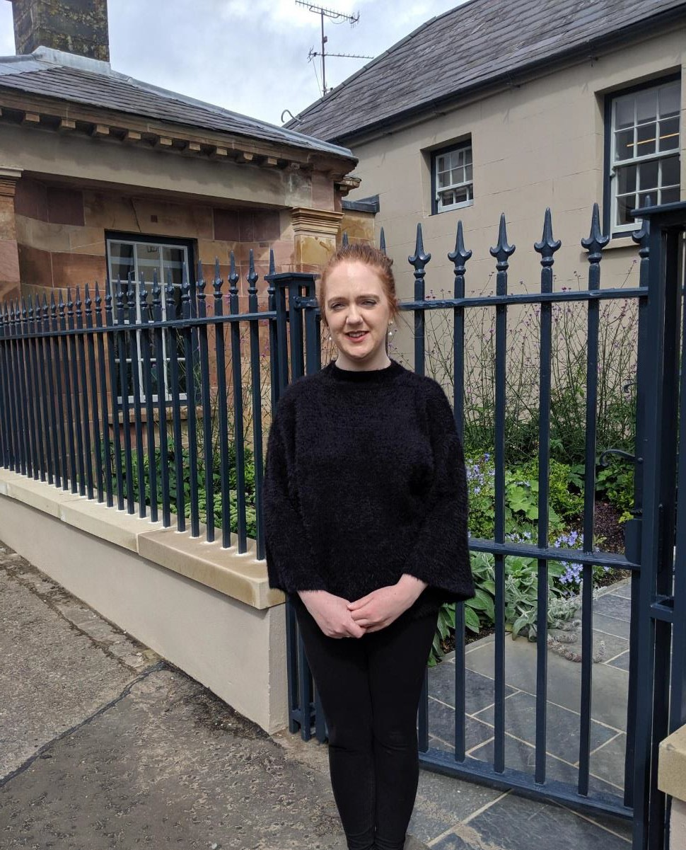When we arrive we will meet Janine

Janine works for Hillsborough Castle and Gardens. She will show us where to go

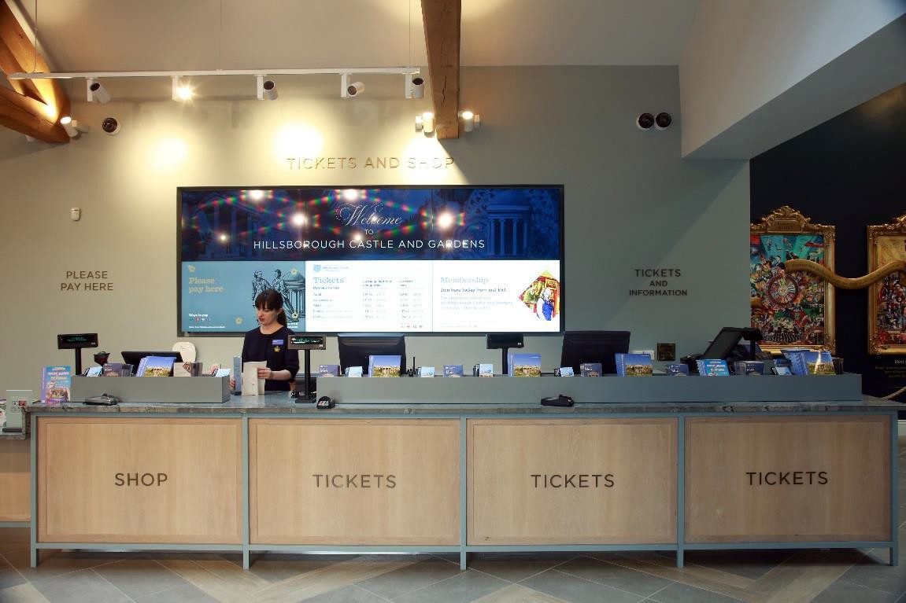We will go through admissions

This area might be bright and
busy with people

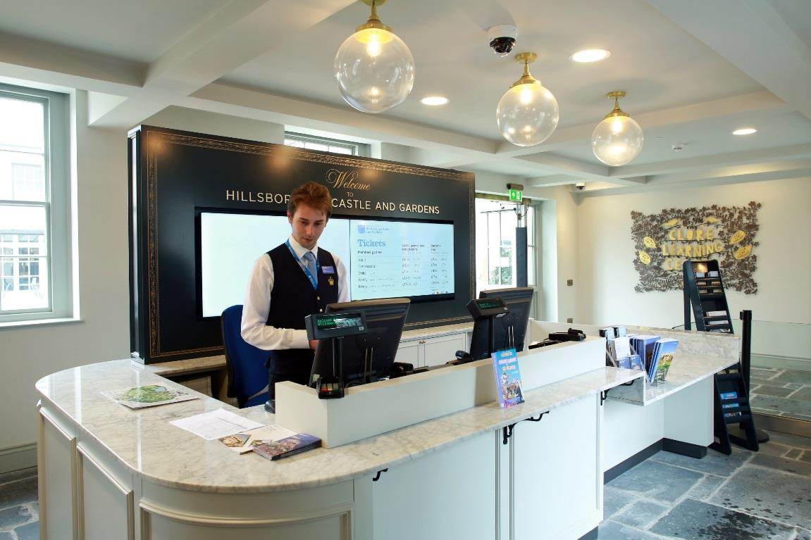The admissions staff wear dark blue uniforms

We might see some
security staff

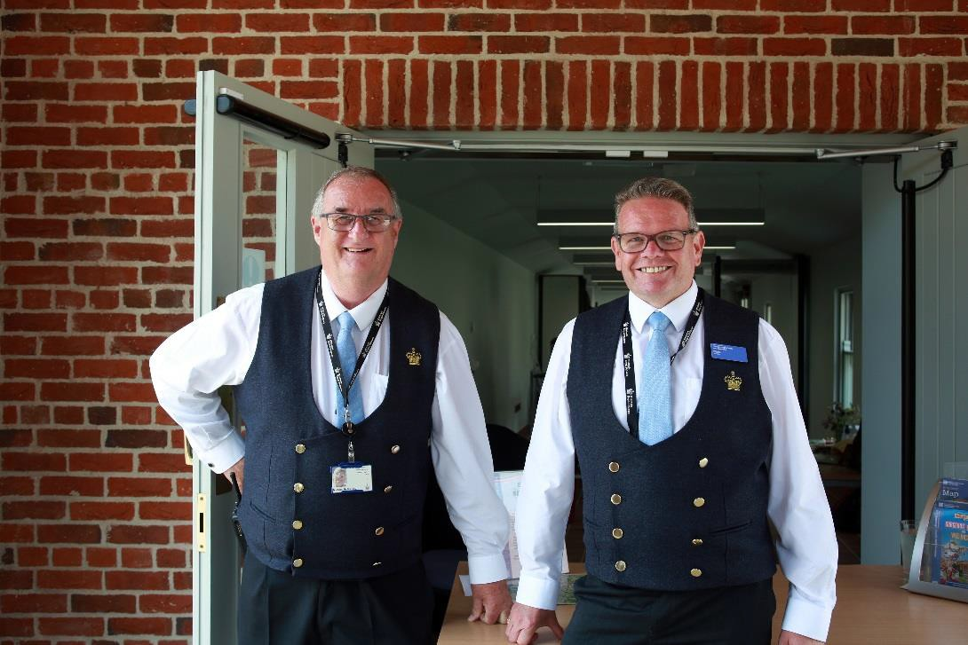The security staff are friendly and help keep Hillsborough Castle and Gardens safe for everyone

If I need to I can ask the security staff for help

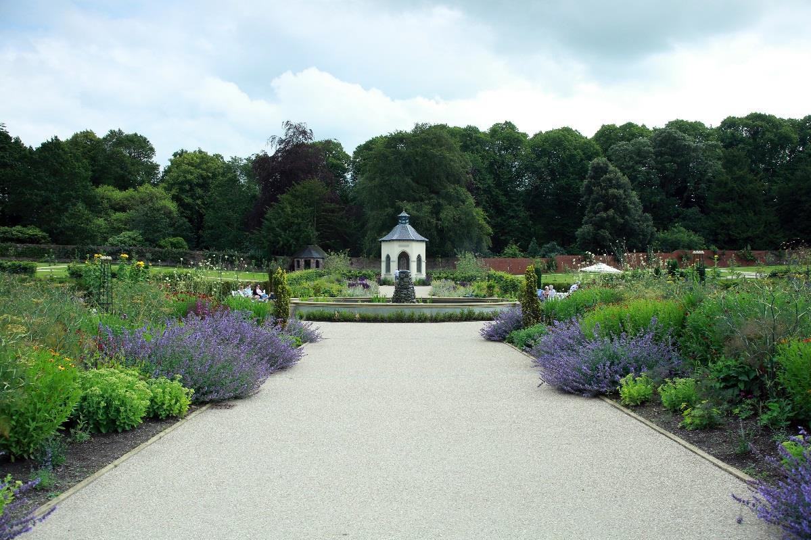We might see the
gardens

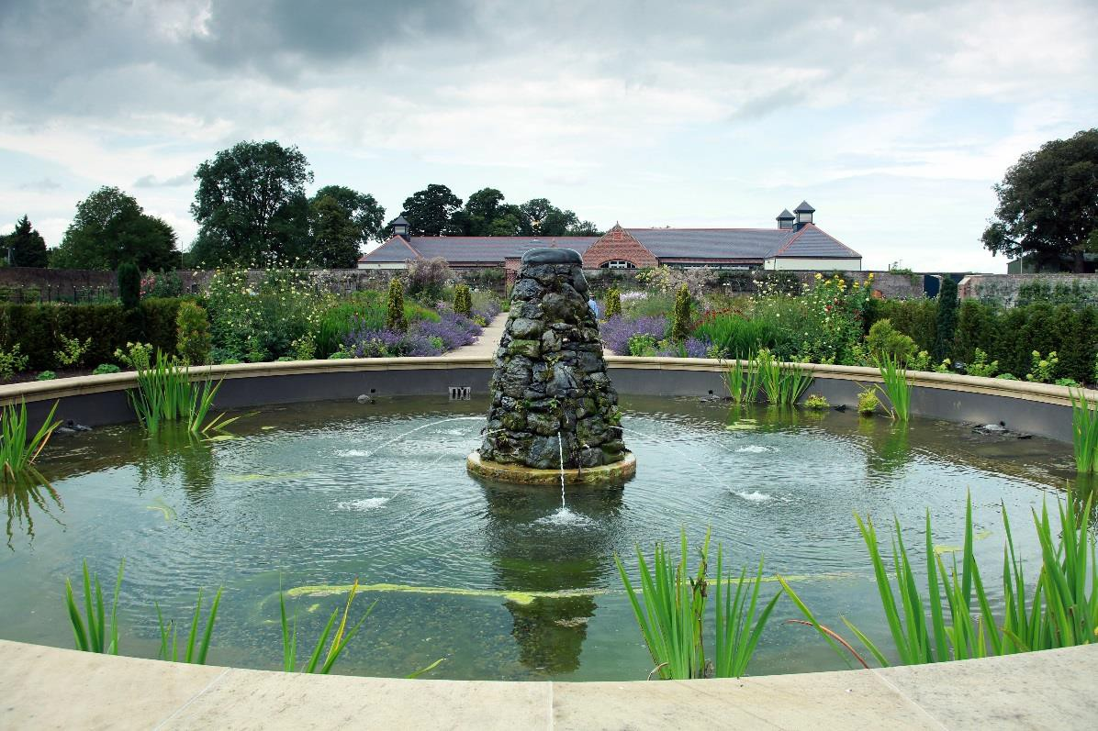The gardens have bright colourful flowers and a water fountain

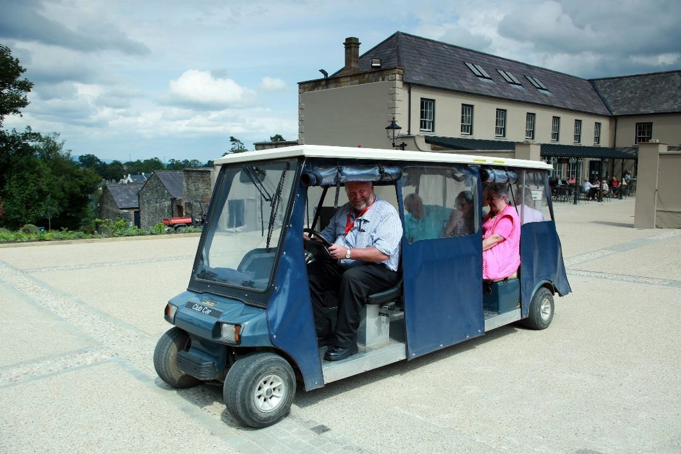We might see a buggy
and driver

We might see some
gardeners

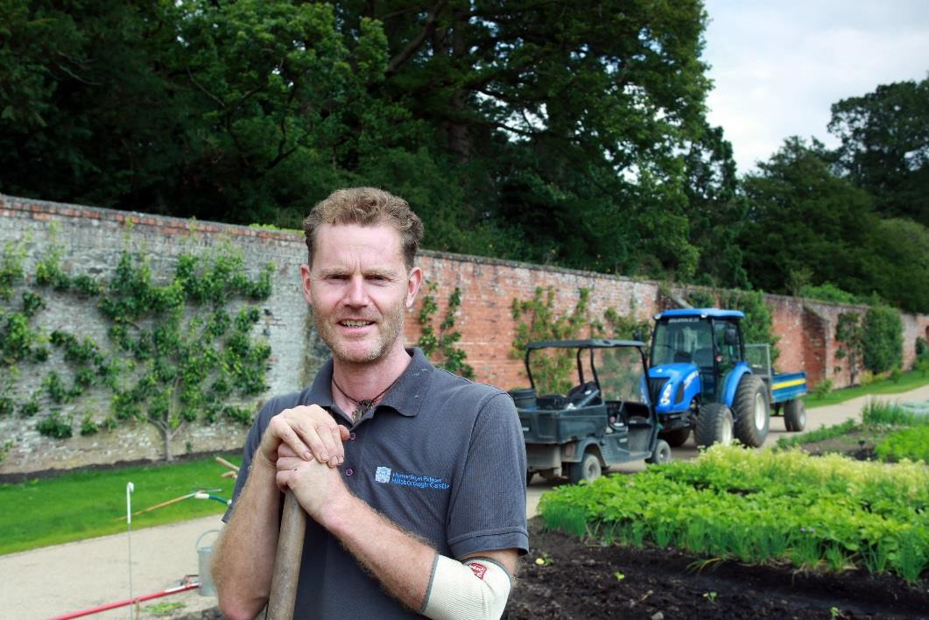

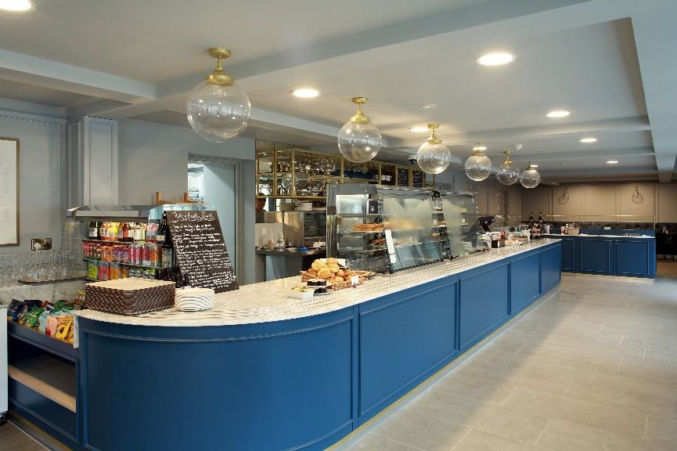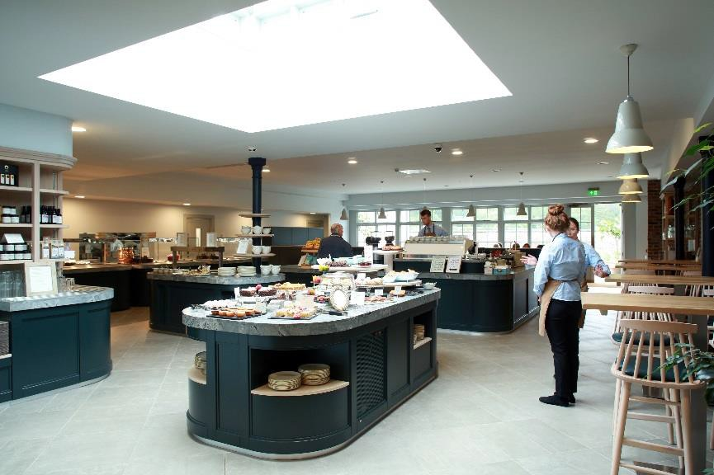We might see the
café

This area might be busy, noisy and smelly

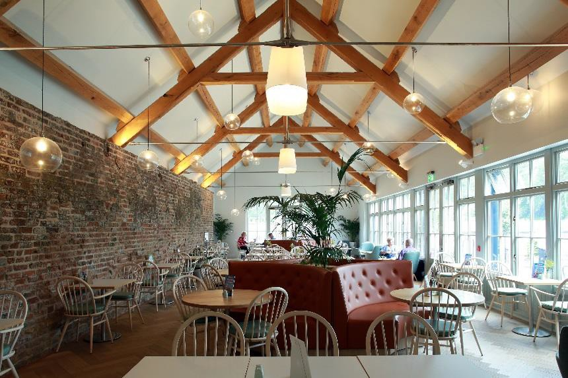The café staff wear blue shirts and brown aprons

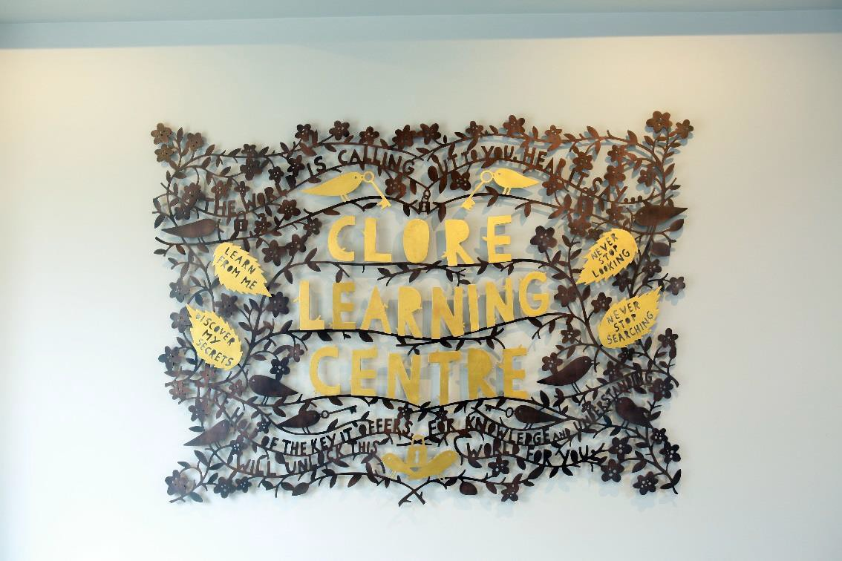We will go to the Clore Learning Centre in the Stable Yard

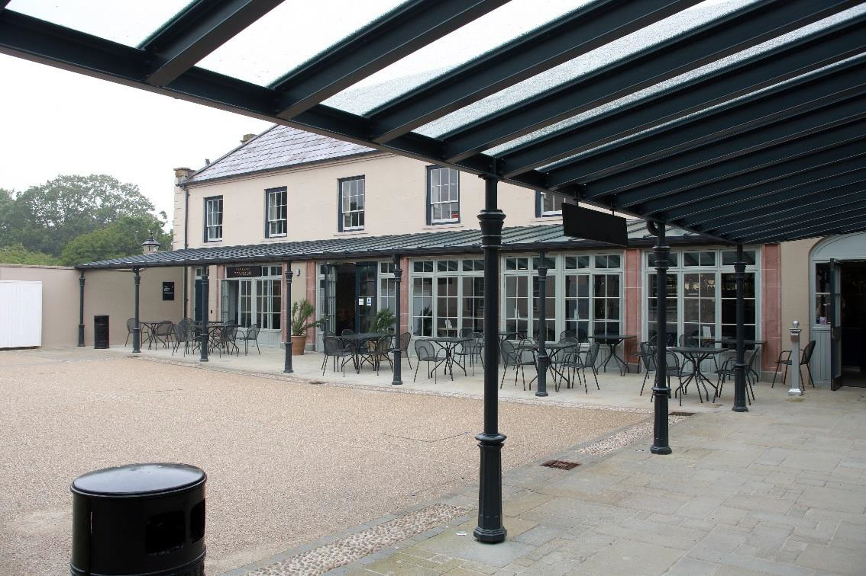The stable yard might be noisy and busy with people

We will go up to the
learning rooms

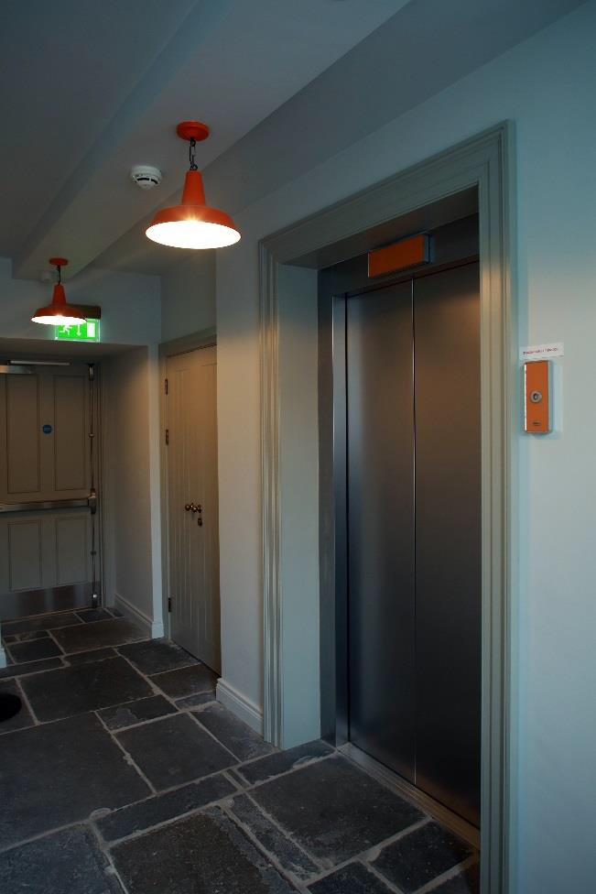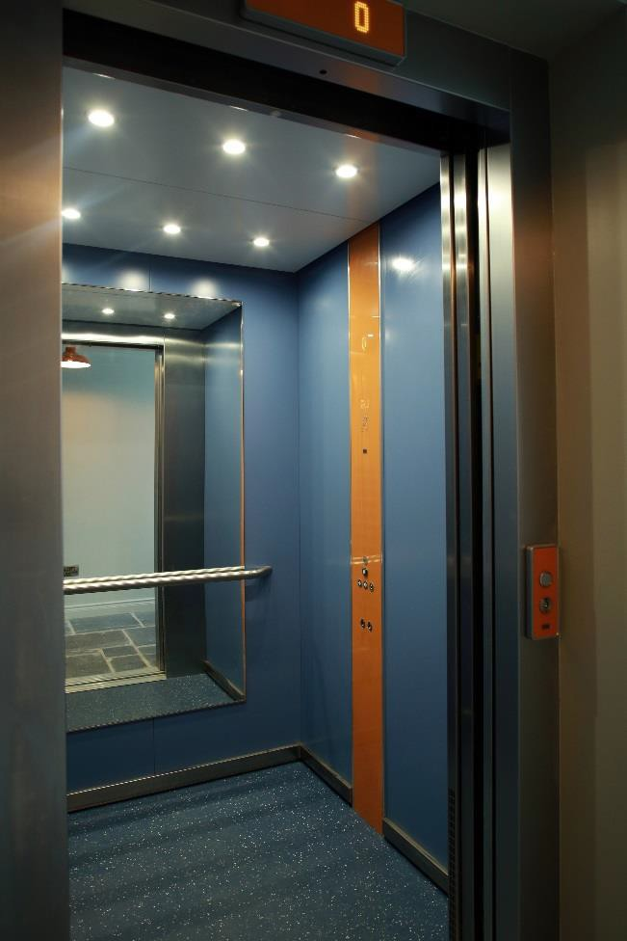I can take the stairs or the lift

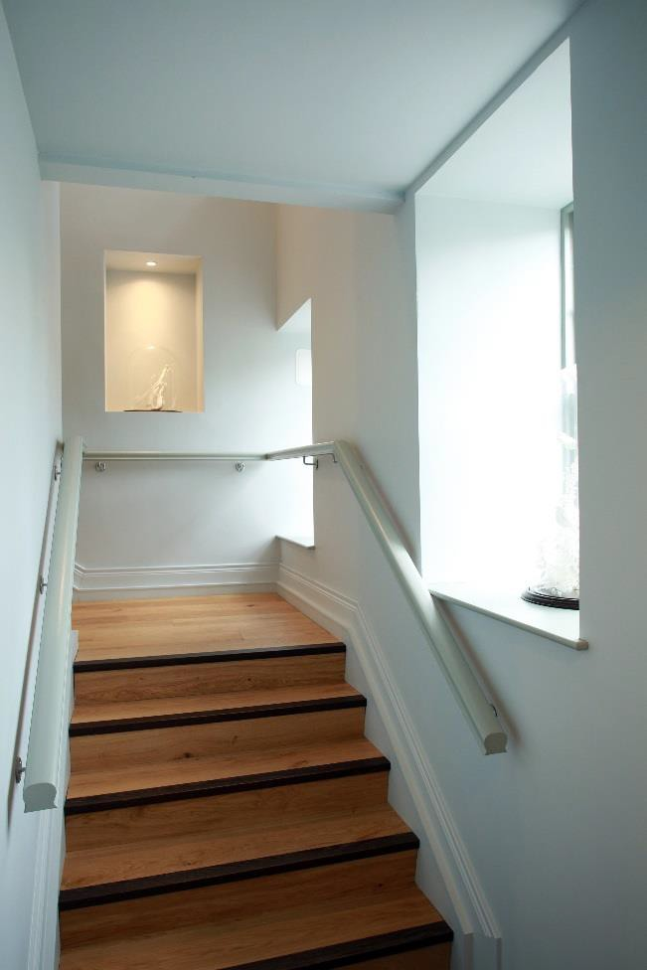

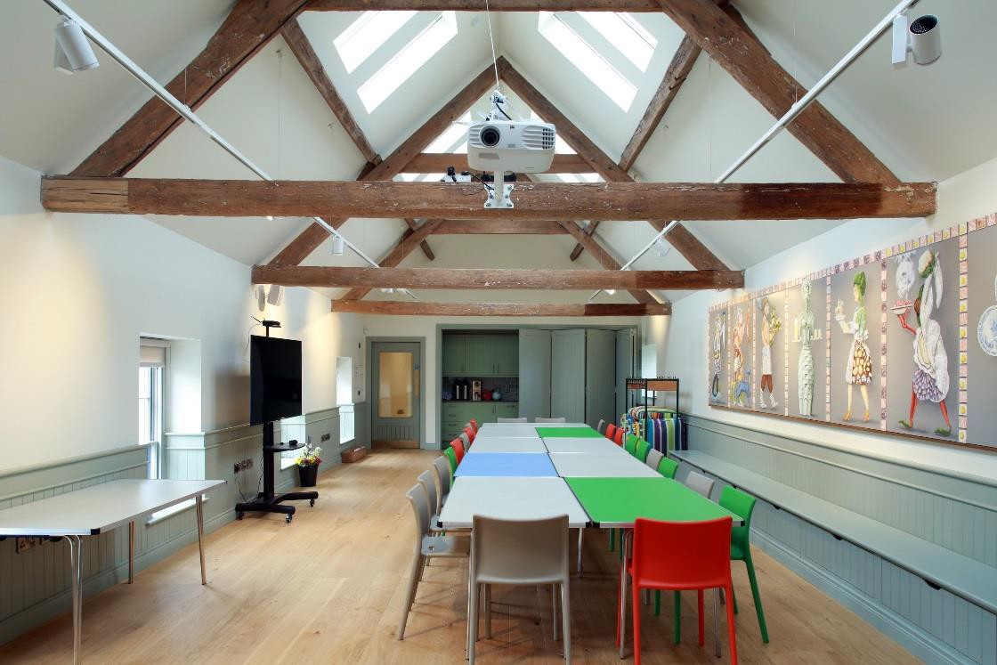The learning rooms are
bright and colourful

There is some art on the
walls

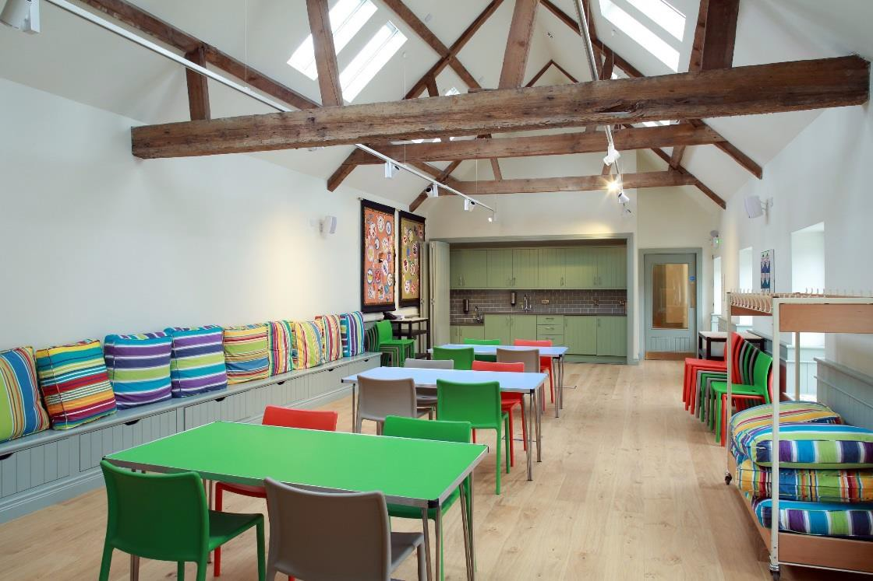The presenter will teach me about Hillsborough Castle and Gardens

If we bring a packed lunch
We will eat it in the learning rooms

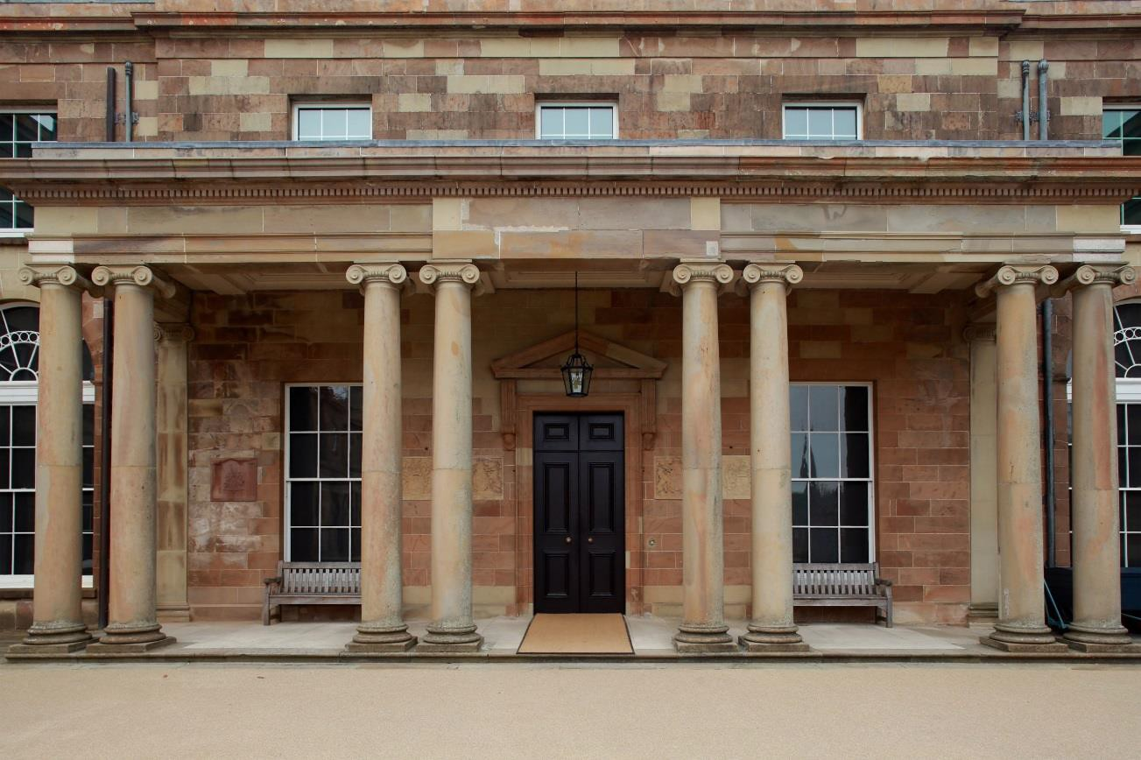The presenter will take us into the house

The house has lots of old paintings and furniture

The presenter will tell me what I can and cannot touch

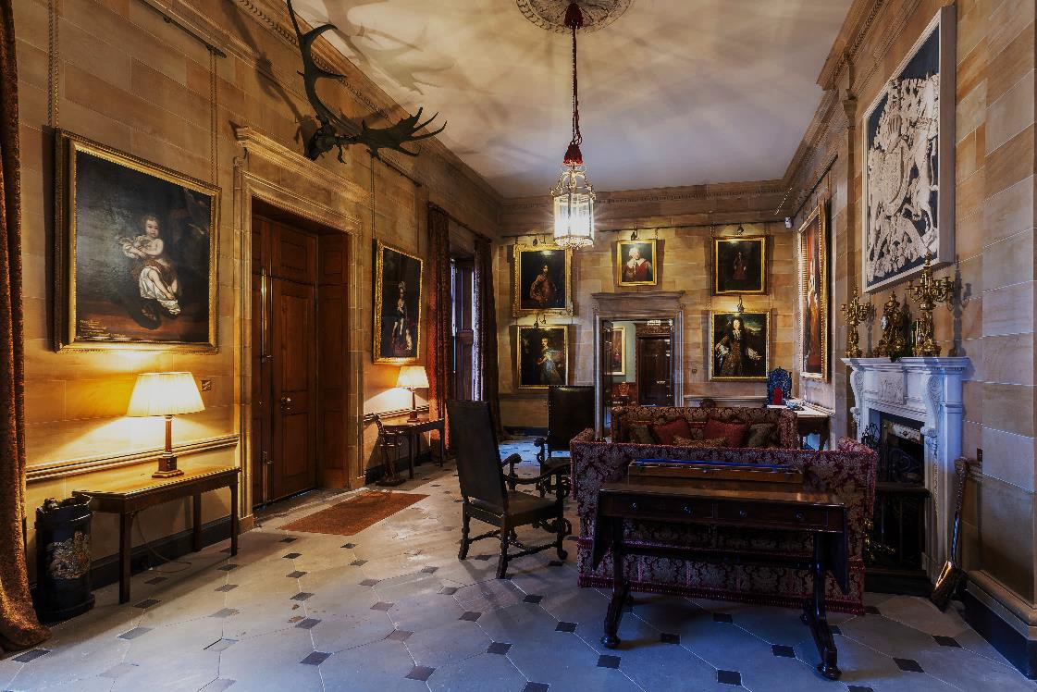We will go into the State
Entrance

The State Entrance might be a bit dark

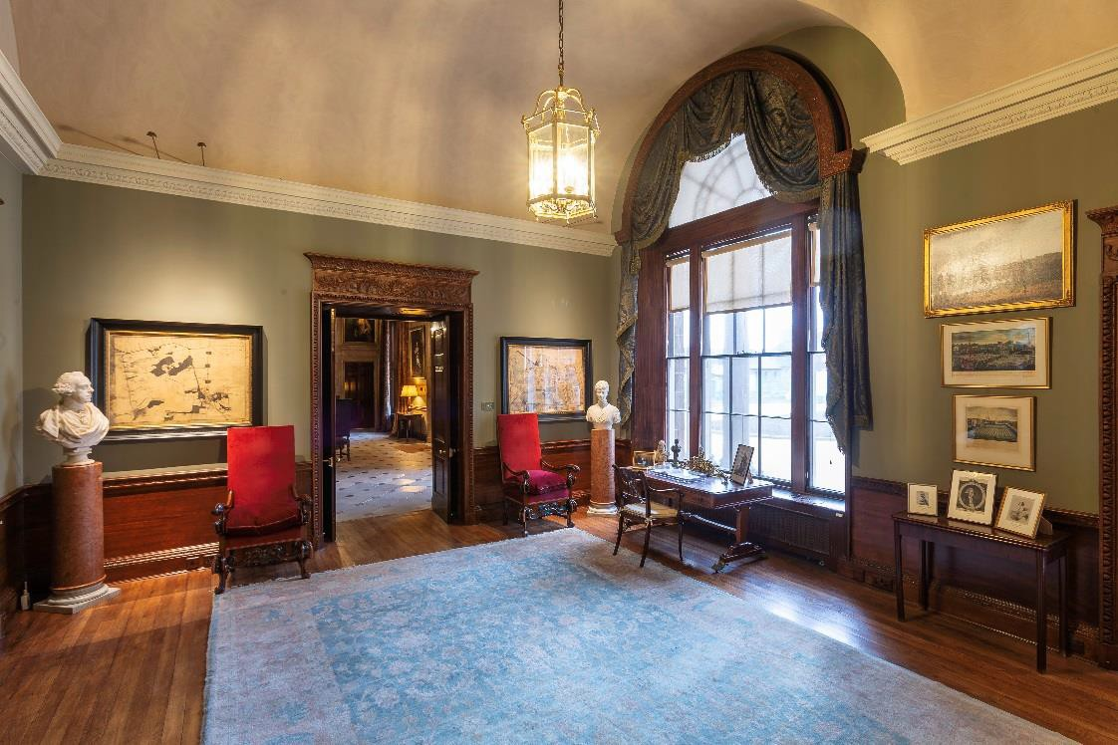Next we will go through the Anteroom

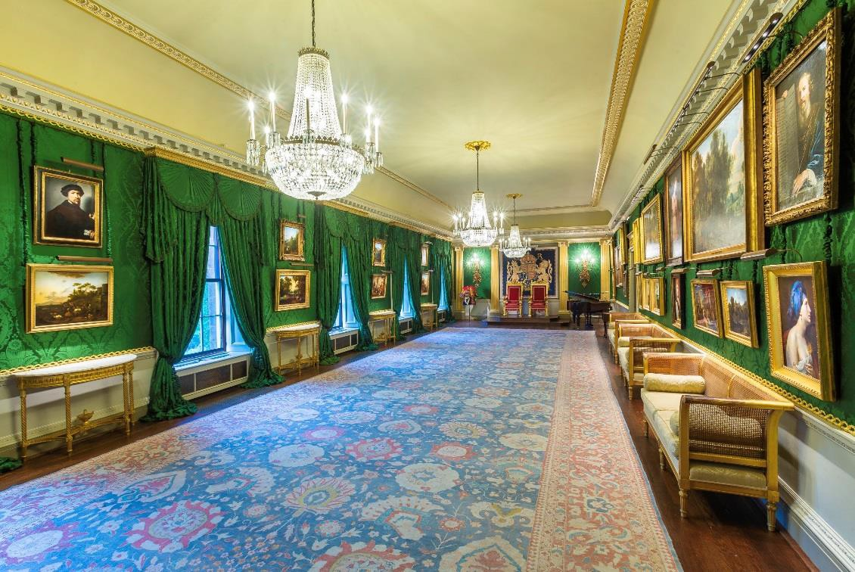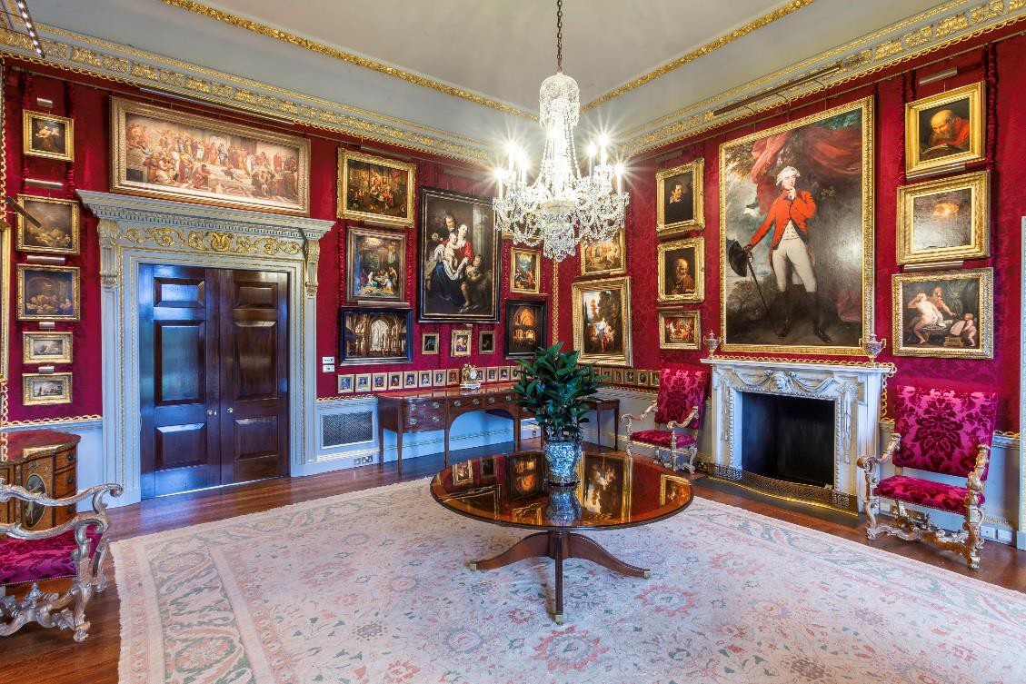We will go to the Throne Room and the Red Room

These rooms have
bright colours

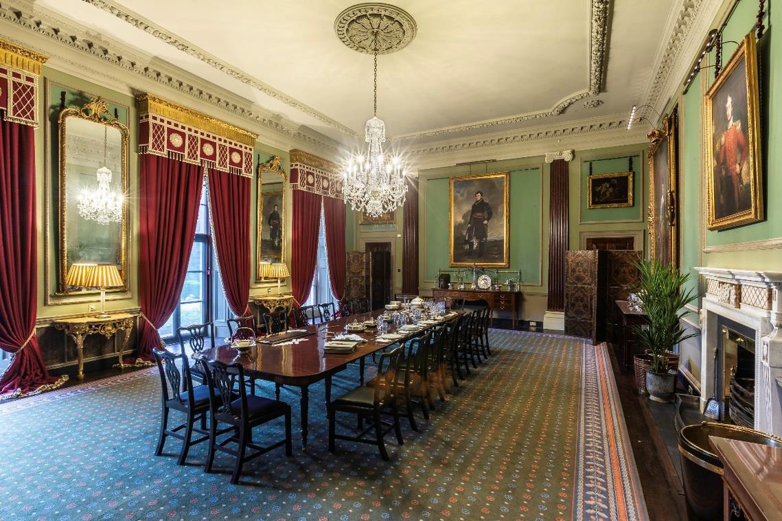We will go to the Dining
Room

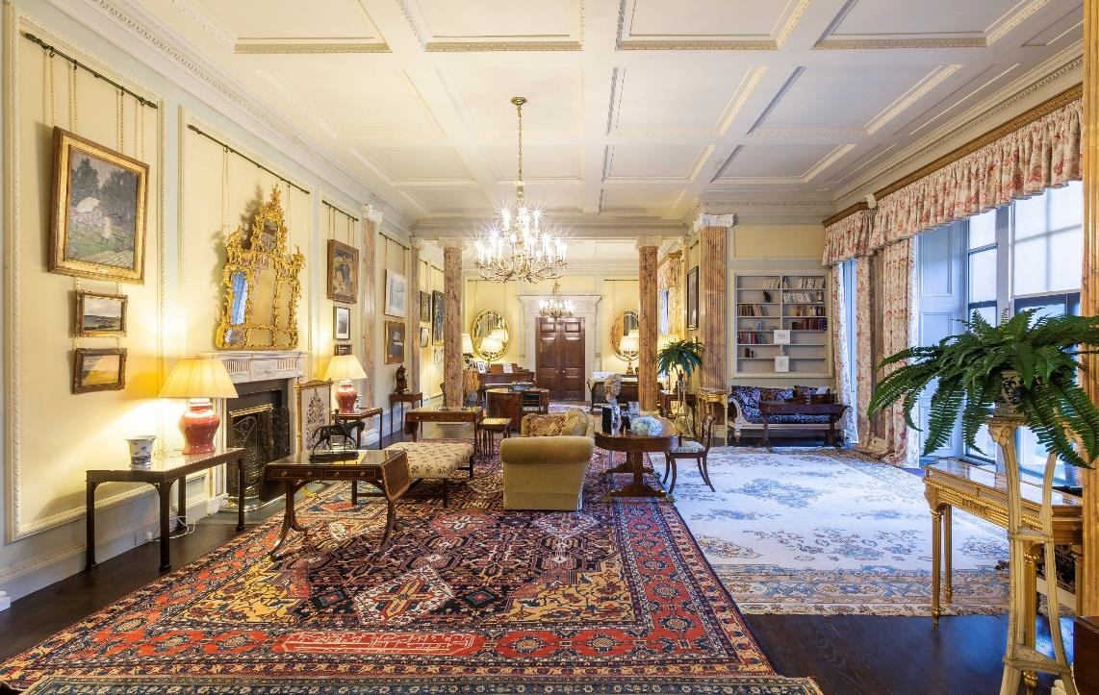and the Drawing Room

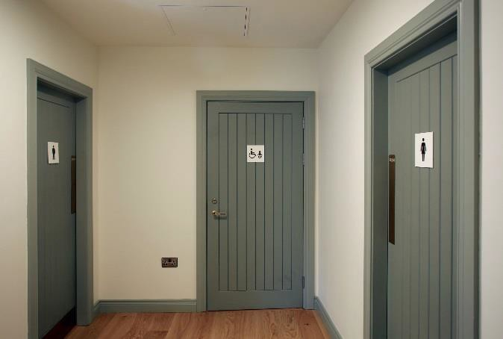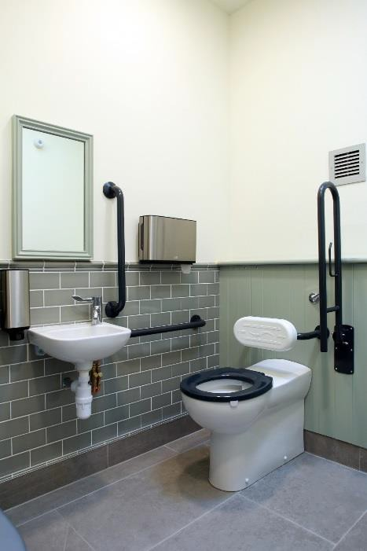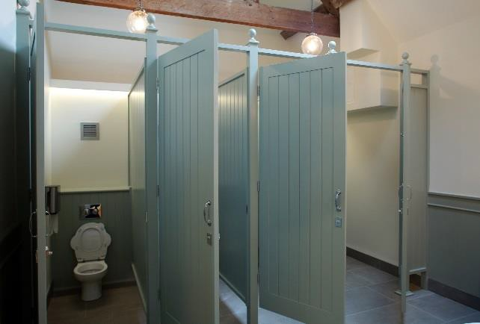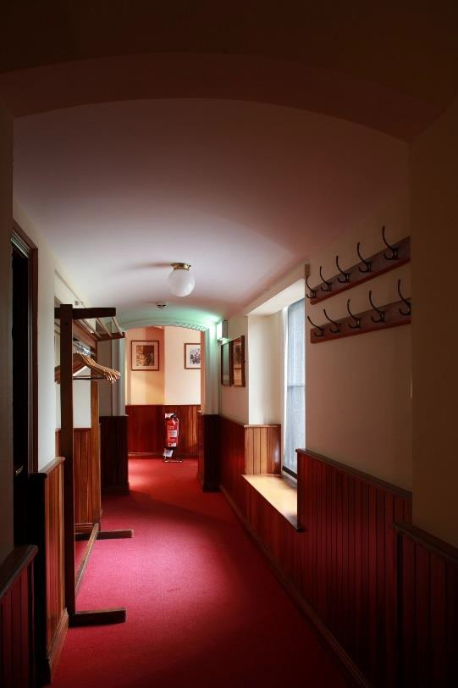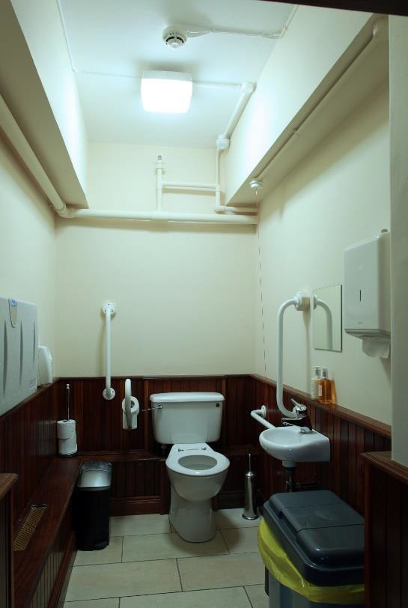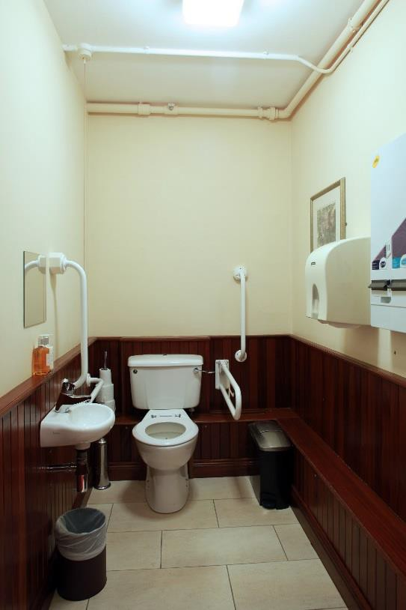If I need to go to the toilet I can use the toilets in the Stable Yard or the Clore Learning Centre

I can also use the toilet inside the house

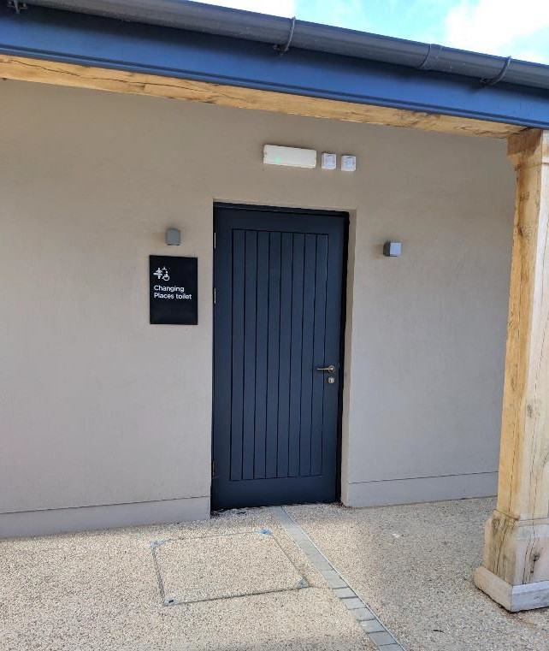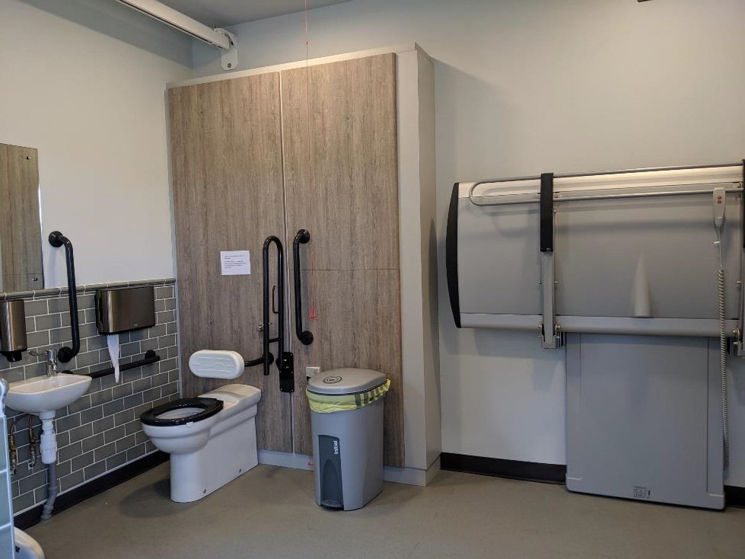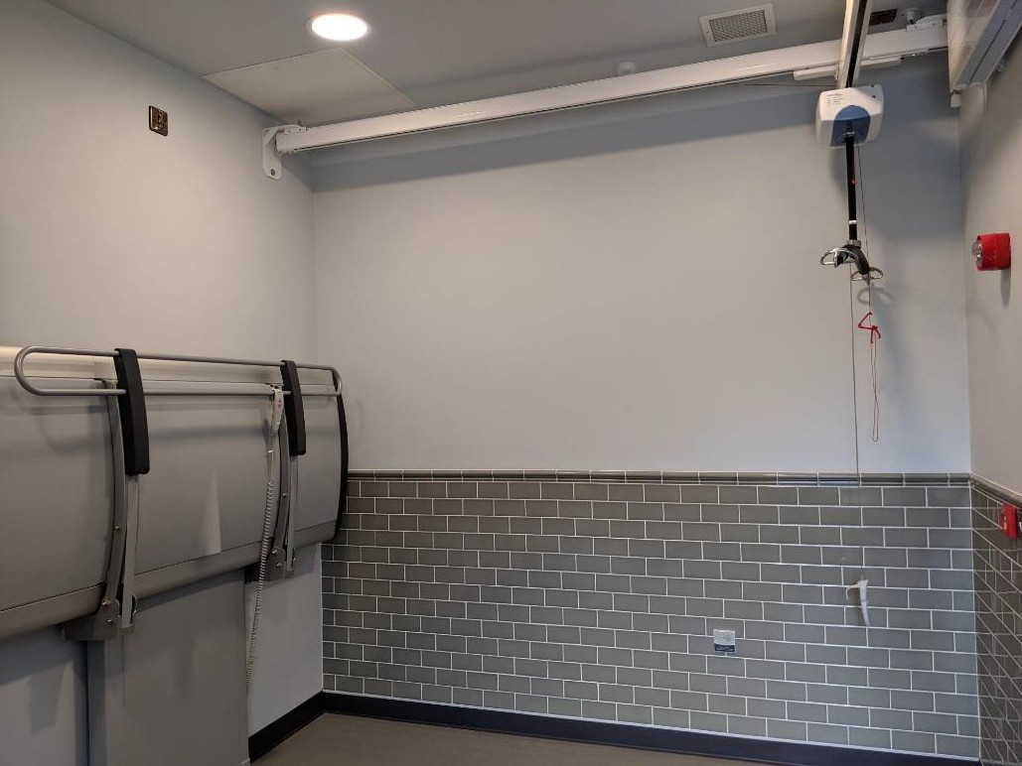There is also a Changing Places Toilet near the entrance at the Lower Site

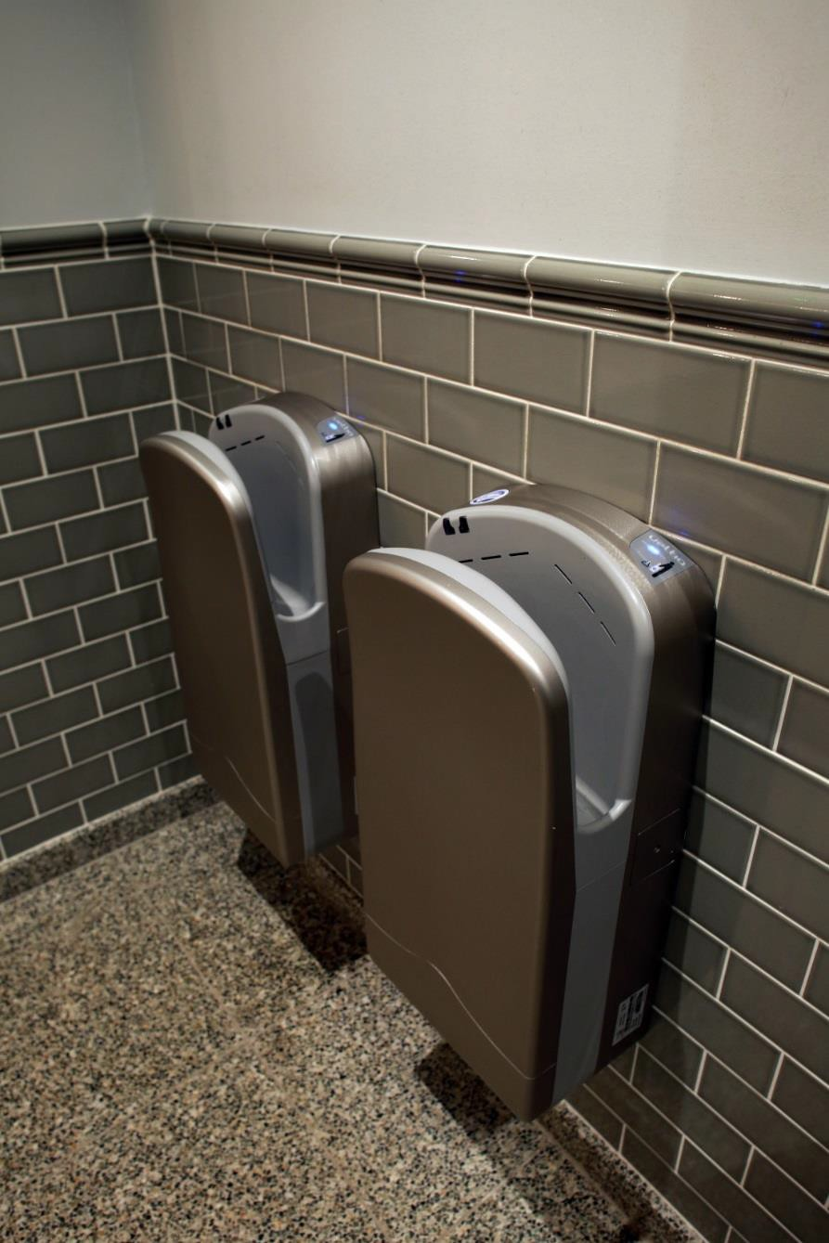The toilets might be
Smelly

Some of them have hand driers that might be noisy

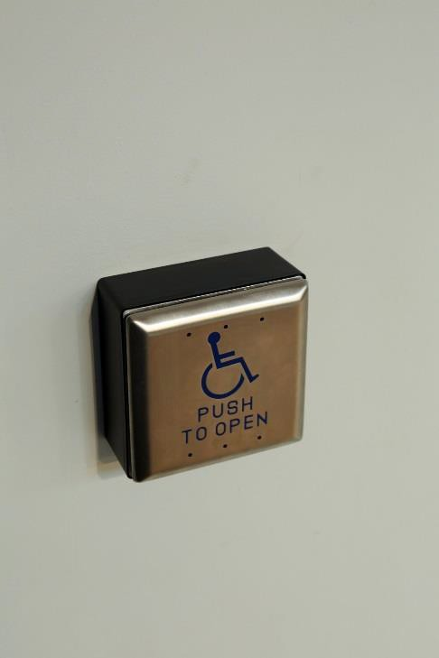Lots of the doors have buttons to press to make them open

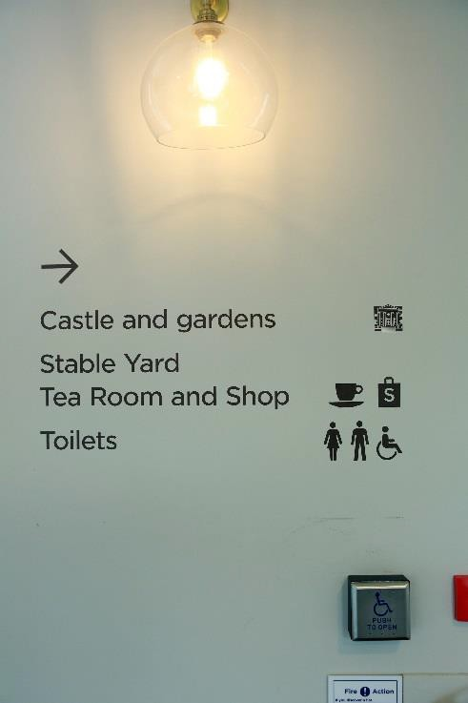There are signs to tell people where to go

I will have a great day at Hillsborough Castle and Gardens!

