Source 1

Chart showing numbers of prisoners at the Tower during the reign of Elizabeth I
Initially seeking to tread a middle path between the two religions of her siblings, Elizabeth was eventually forced to establish a Protestant regime due to a lack of cooperation from both sides and her excommunication by the Pope in 1570. Continued religious tensions, heightened by the threat of invasion from Catholic countries abroad, were ever present during Elizabeth’s reign.
Famously the Virgin Queen, Elizabeth also managed to evade and subdue the threats associated with the succession of power. By the end of her reign a highly sophisticated and effective spy network existed which, along with her personal influence, helped to assuage the many threats that Elizabeth faced, and to which the prisoner statistics testify.
Where might these five events lie on the graph?
- Northern Uprising & Excommunication
- Ridolfi Plot
- Parliament Act to retain the Queen’s Majesty’s Subjects in true obedience
- Essex Rebellion
- Babington plot
How do you think Elizabeth’s use of the Tower compares that of the other Tudors?

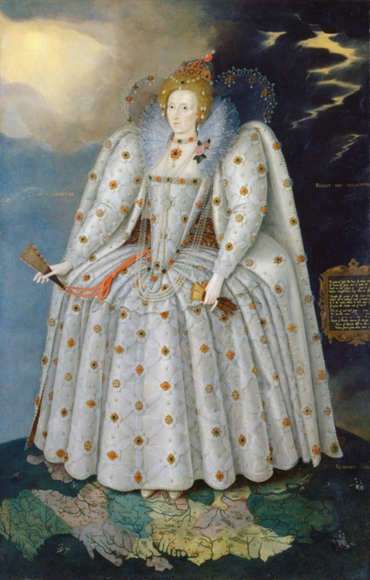
Source 2
Portrait of Elizabeth I, Marcus Gheeraerts the Younger, c.1592
Portraits can give insight in to the image a monarch is trying to project and the ideals of clothing and appearance at the time. This painting was created quite far into Elizabeth’s reign.
What is Elizabeth saying with this image?
Use the following questions to analyse this
portrait
- Which way is Elizabeth looking?
- What is in the background around her head?
- What is she standing on?
- What is she wearing?
- What is hanging down at the point of her bodice?

What image is she trying to project with this portrait?

