School resource

Espionage and the

First World War

Key Characters

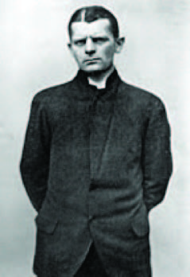  Carl Hans Lody  1877 - 1914 |  | Carl Hans Lody was a Junior Lieutenant in the German Naval Reserve. Despite having limited training in espionage he was sent to spy in Britain and Ireland during the First World War.  Before the war, Lody had been married to an American and spoke fluent English. He travelled using an American passport in the name of Charles A. Inglis to avoid detection.  Lody was originally given the task of reporting from southern France, but was sent to Britain in August 1914 and tasked with reporting on the activity of naval bases in the Edinburgh-Leith area.  Lody’s only means of communication with his superiors in Germany was by telegrams and letters to neutral countries. He sent a number of telegrams using a simple code, but was finally arrested on 2 October 1914 when one of his uncoded messages was intercepted by postal censors. On his person officials found 705 Norwegian kroner, £14 in German gold, a notebook containing lists of ships sunk in the North Sea and a hollowed out book containing pills.  Lody was taken to London where he was put on trial for war treason and sentenced to death by firing squad. On the day before his execution Lody wrote two letters, one to his guards at the Tower, thanking them for their kindness, and the other to his family informing them of his death.
Judge Kenneth Marshall |  | Judge Kenneth Marshall was a member of the Judge Advocate General responsible for Army and RAF courts martial. Judge Advocates were civilian lawyers employed by the War Office to advise at courts martial. Judgement itself was delivered by a panel of officers.  The General courts martial of Carl Lody took place at the Middlesex Guildhall in Westminster between 30 October and 2 November.  Carl Lody, also known as Charles A. Inglis, was charged with two offences under the Defence of the Realm regulations. He pleaded not guilty to both charges:  - Attempting to convey information calculated to be useful to an enemy by sending a letter from Edinburgh on 27 September 1914 to Herr J. Stammer in Berlin, which contained information with regard to the defences and preparations for war of Great Britain.  - Committing war treason against Great Britain by sending a letter from Dublin, around 30 September 1914, to Herr J. Stammer in Berlin which contained information with regard to the defence and preparations for war of Great Britain.
Commander Fritz Prieger |  | Carl Hans Lody was a personal acquaintance of the first director of German Naval Intelligence, Commander Fritz Prieger.  In May 1914 he volunteered for service with the department and was tasked with conveying information to the German secret services pertaining to the activity of the Naval bases in the Edinburgh-Leith area.  The Firth of Forth, the large estuary to the north of Edinburgh, was of great strategic importance. As well as being the main seaward approach to the Scottish capital and the site of the Forth Bridge, it was used as an anchorage by dozens of Royal Navy ships. The area was heavily fortified with gun batteries and minefields to protect it against attacks from the sea. The Germans wanted to obtain information on the British fleet and defences, as well as the aftermath of any engagements.  At his trial in October 1914 Lody admitted that he had been a spy but refused to name Fritz Prieger, the person who had recruited him: “that name I cannot say as I have given my word of honour”.  His declarations of patriotism and honour attracted widespread admiration in both Britain and Germany.
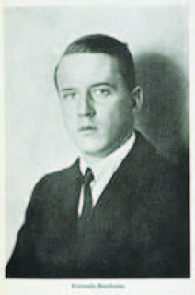  Fernando Buschman  1890 - 1915 |  | Born in Brazil, Buschman was one of 11 German spies executed at the Tower between the years 1914 and 1916.  Fernando Buschman was a businessman involved with the import and export of food and had connections in Brazil, London and Hamburg. After the outbreak of the First World War his business began to suffer and he travelled to London to make contact with some of the food merchants that he suspected had ceased to trade with him because of his German interests.  Money was short and in 1915 Buschman began sending telegrams to a contact in Hamburg named Flores Dierks requesting money. Dierks was known by the British security forces as a major organising officer for spies sent to the UK. The last telegram that Buschman sent was to the German military and linked Flores to the German intelligence service. When Buschman was arrested officers searched his rooms and found a notebook entitled ‘Impressions of London’ filled with comments on the similarities between Paris and London.  Buschman was court marshalled and, although he claimed that he knew nothing of military matters, he couldn’t explain his communications with the German military. He was found guilty and sent to the Tower to await his execution.  On the night before his death Buschman played his violin until the early hours before finally kissing the instrument and saying ‘Goodbye, I shall not want you anymore’.  He was executed by a firing squad at the Tower on 19 September 1915.
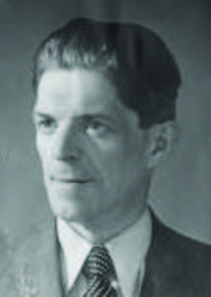  Josef Jakobs  1898-1941 |  | By the 20th century the Tower served primarily as a museum. One role that it did retain was that of an enduring symbol of the monarchy and British Empire – standing defiant in the face of Nazi onslaught.  It was for this reason, in August 1941, that Josef Jakobs became the last person to be executed at the Tower.  Six months earlier Jakobs had been discovered on farmland lying beneath a camouflage parachute. He protested his innocence but was soon discovered to be in possession of a number of incriminating items, including a wireless transmitter, false papers and maps of nearby RAF bases.  At a court martial Jakobs was found guilty of espionage and lodged overnight in the east turret room of the Waterloo Block before being executed by a firing squad. The chair used for his execution can be found in the Royal Armouries’ collection.

