School Resource

History of Kensington Palace

Palace People

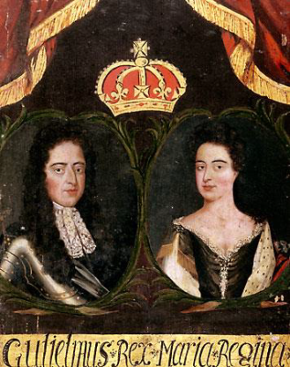  William III and Mary II  (r. 1689-1702) |  | - Famous for being the only British monarchs to have ruled jointly.  - Bought Nottingham House for £20,000 in 1689 and transformed it into Kensington Palace.  - Mary was a great homemaker. She had a massive collection of ceramics which were arranged in her rooms at Kensington Palace.  - In 1694, Mary died suddenly of smallpox at Kensington Palace.  - In 1702, William died at Kensington Palace following a riding accident at Hampton Court Palace.
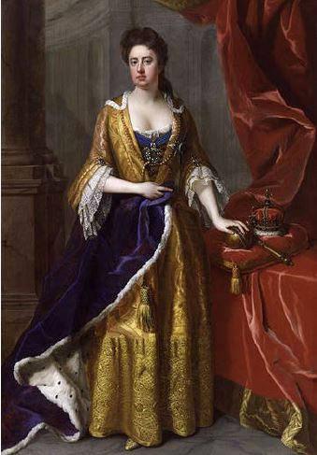  Queen Anne  (r, 1702-1714) |  | - Sister to Mary II, Queen Anne ascended the throne following William III’s death.  - Anne’s greatest achievement was the Act of Union (1707) which saw England and Scotland join to create a single Kingdom.  - Anne spent £26,000 on improving the gardens at Kensington, including the construction of the Orangery.  - Anne had eighteen pregnancies, most resulted in miscarriages and only one child, William, lived more than a year. William died when he was eleven years old.  - In 1714, Queen Anne died at Kensington Palace.

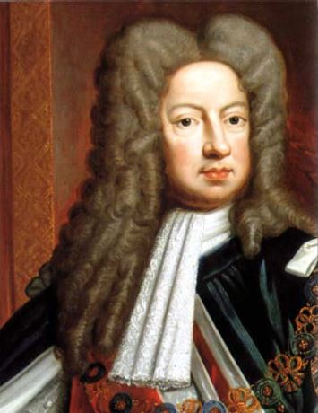  George I  (r. 1714-1727) |  | - George I was born in Hanover, Germany.  - In October 1714, George became King of England and visited Kensington Palace for the first time.  - George was an unpopular monarch and struggled to learn English.  - In the spring of 1726, George I brought Peter the Wild Boy, a feral child from Germany, to the Kensington Court.  - George I died on 11 June 1727 during a visit to Hanover and was succeeded by his son, George II.
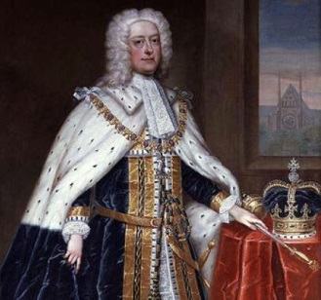  George II  (r. 1727-1760) |  | - George II and his wife, Queen Caroline, moved into Kensington Palace following the death of George I.  - George II and Queen Caroline had nine children.  - George quarrelled constantly with his eldest son, Frederick, Prince of Wales, and in 1737 he banished Frederick, his wife and their family from court.  - George II died on 25 October 1760 on the toilet at Kensington Palace.
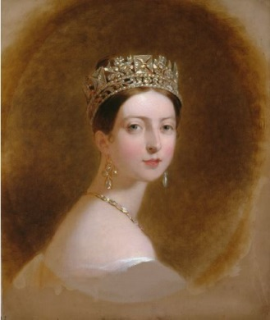  Queen Victoria  (r. 1837-1901) |  | - On 24 May 1819, Princess Victoria was born at Kensington Palace where she spent her childhood.  - The young princess loved dancing, riding, drawing and her pet dog, Dash.  - At Kensington Palace, just weeks after her 18th birthday, Victoria was told she was going to be Queen.  - Victoria met her future husband, Prince Albert, at Kensington Palace.
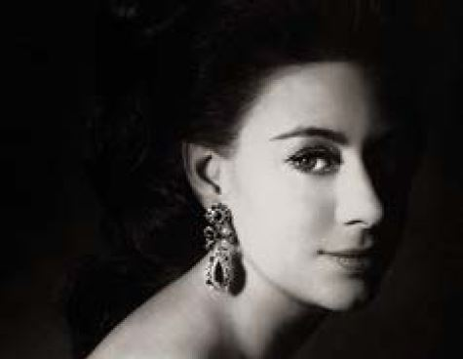  Princess Margaret |  | - Princess Margaret was the younger sister of our current Queen.  - Margaret was extremely stylish and fond of parties.  - Margaret lived at Kensington Palace for nearly 42 years until her death in February 2002.
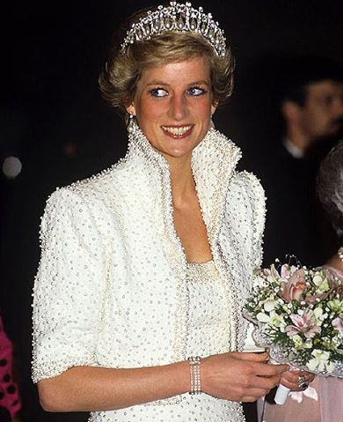  Diana, Princess of Wales |  | - Diana, Princess of Wales, was married to Prince Charles and mother to Prince William and Prince Harry.  - Diana’s engagement ring cost £30,000 and it is estimated her wedding to Prince Charles was watched by 750,000,000 worldwide.  - She lived at Kensington Palace from the time of her wedding, 29 July 1981, until her death on 31 August 1997.  - Diana’s tragic death in Paris in 1997 shocked the world and Kensington Palace became the focus of public mourning in London. Flowers appeared at the front of the south gates of the Palace. It is estimated more than a million bouquets were left there. Kensington Palace stayed open for 24 hours a day to cope with the 136,000 mourners who came to sign the condolence books.

