School resource

Henry VIII’s Six Wives
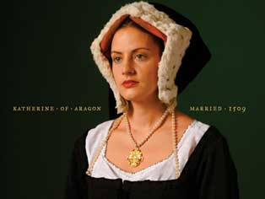  Katherine of Aragon |  | - The first of Henry VIII's six wives, Katherine of Aragon (1485-1536) was a Spanish princess who was married to Henry for 18 years before he began divorce proceedings in his desperation to re-marry and produce a male heir.  - Katherine had been pregnant six times but only one daughter, Princess Mary, later Mary I, had survived. Dying in 1536, Katherine wrote to Henry: 'Lastly, I make this vow, that mine eyes desire you above all things. Farewell.'
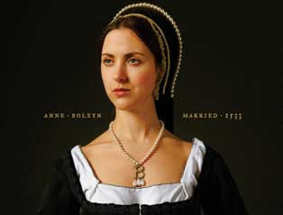  Anne Boleyn |  | - The second of Henry VIII's six wives, Anne Boleyn (c1501-36) was married to the King for only three years from 1533-6.  - Instead of the sought after male heir, Anne was pregnant with another princess, Elizabeth (later Elizabeth I).  - Anne was supported by religious reformers but was also hated by many at court. After a miscarriage, her fate was sealed and she was arrested (and later executed at the Tower of London) for adultery and incest.
Jane Seymour  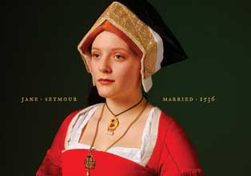 |  | - Jane Seymour (c1509-37) was the third of Henry VIII's six wives and the only wife to provide the King with the much longed for son and male heir.  - Having married Henry in May 1536, she gave birth to Prince Edward (later Edward VI) at Hampton Court Palace in 1537 but died soon afterwards.  - Henry had his son but grieved: 'Providence has mingled my joy with the bitterness of the death of her who brought me this happiness.'
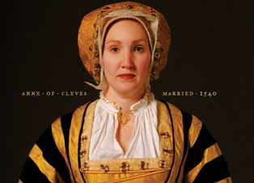  Anne of Cleves |  | - Anne of Cleves (1515-1557) was the fourth of Henry VIII's six wives and at 24 was half Henry's age when they married in January 1540.  - Henry first saw Anne of Cleves in a painting by Hans Holbein but in the flesh, Henry found Anne unattractive and began pursuing one of her maids of honour, Catherine Howard.  - After six months the marriage was annulled yet Anne remained in England and on good terms with Henry VIII. He commanded that she be treated as 'the king's sister'.
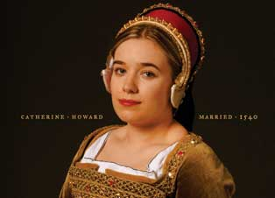  Catherine Howard |  | - Henry VIII's fifth wife was an alluring teenager named Catherine Howard (c1522-1542).  - They married only three weeks after his second divorce.  - After less than two years of marriage, rumours of Catherine's past and present love affairs reached a furious Henry.  - She was arrested at Hampton Court Palace and later taken to the Tower of London where she was beheaded in February 1542, aged about 21.
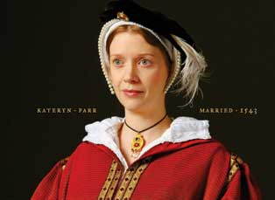  Kateryn Parr |  | - Kateryn Parr (1512-48) was the last of Henry VIII's six wives.  - Intelligent and devout, Kateryn loved Thomas Seymour but Henry's proposal could not be refused. She and Henry VIII married at Hampton Court Palace in July 1543. He was 52, she was 31.  - After the King's death in 1547, Kateryn was free to marry Seymour but she died 15 months later, aged 36, having given birth to their daughter.

