Henry VIII to Mary I:

A religious rollercoaster

Key characters

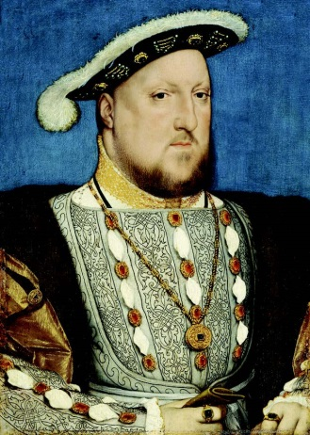  Henry VIII  1491 – 1547  Reigned: 1509 - 1547 |  | Henry became heir to the English throne on the death of his older brother Arthur in 1502.  In his youth Henry was a handsome man and an accomplished musician, writer and sportsman. He was also highly intelligent. In 1521 Pope Leo X gave him the title ‘Defender of the Faith’ for his book attacking the reforming ideas of Martin Luther and affirming the supremacy of the Pope.  The second half of Henry’s reign was dominated by two issues: the succession and the Protestant Reformation.  Henry was acutely aware of the importance of securing a male heir during his reign but so far his marriage to Katherine of Aragon had produced a daughter, Mary, but no son.  Henry looked instead to Anne Boleyn and asked the Lord Chancellor, Cardinal Thomas Wolsey, to appeal to the Pope for an annulment, on the grounds that his marriage to Katherine had never been legal.  Wolsey failed in this task and, in 1533, Henry broke with the Church and married Anne Boleyn. He was excommunicated by the Pope and the English Reformation began, forcing clergy and courtiers to choose their allegiances.  After Wolsey’s downfall, Thomas Cromwell helped to establish Henry as head of the Church in England and brought him much needed wealth through the dissolution of the monasteries.  Henry’s reformation produced dangerous Protestant-Roman Catholic differences in the kingdom and encouraged ambitious Tudor court factions. Despite the growing number of his subjects who adopted Protestantism, Henry’s personal religious beliefs remained Catholic.  Henry died on 28th January 1547 and is buried at St George’s Chapel, Windsor, alongside his third wife and the mother of his son, Jane Seymour.
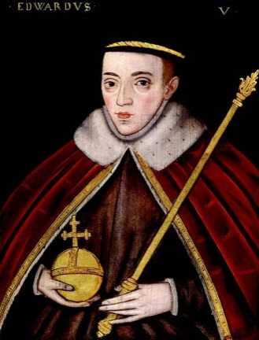  Edward VI  1537 - 1553  Reigned: 1547 - 1553 |  | Edward was born on 12 October 1537 at Hampton Court Palace, the son of Henry VIII and Jane Seymour, who sadly died a few days after his birth.  Edward was given a rigorous education to prepare him for his future role as king. He was a sickly child and his father went to great lengths to protect him from the plagues and sicknesses that afflicted the court.  Edward became king in 1547 at the age of nine. Because of Edward’s young age, Henry had arranged for a council of regency to rule on his behalf. This council soon succumbed to factionalism and Edward’s uncle, Edward Seymour, established himself as Protector.  The young king was fiercely Protestant and his short reign was dominated by attempts to transform England into a truly Protestant state, eradicating many Roman Catholic practises. A new English Prayer Book issued in 1549 proved unpopular and led to rebellions and uprisings in the West Country.  At the same time Kett’s Rebellion raged in Kent against economic and social injustices such as land enclosures. As Protector, it was Seymour’s duty to suppress these uprisings. When he failed the Duke of Northumberland stepped in, subsequently overthrowing Seymour who was arrested and later executed.  Soon after this the young king contracted tuberculosis and his health began to fail. Anxious that his religious reforms should not be undone, Northumberland persuaded Edward to alter the line of succession and accept Lady Jane Grey, Northumberland’s daughter-in-law, as his heir in place of the Catholic Mary Tudor.  On his death in 1553, Northumberland’s persistence paid off and Jane assumed the throne.
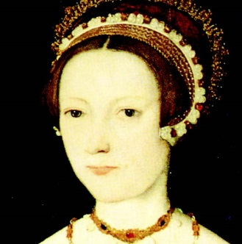  Lady Jane Grey  1537-1554  Reigned: 10 July to 19 July 1553 |  | Lady Jane Grey ruled as Queen of England for just nine days in 1553 as part of an unsuccessful bid to prevent the accession of Mary Tudor.  As great granddaughter to Henry VII, Jane entered Kateryn Parr’s household at the age of 10 where she was exposed to a strongly Protestant and academic environment.  When Henry VIII died in 1547 his 9 year old son Edward was crowned king. Edward’s brief reign was blighted by nobles using the Regency to strengthen their own positions. When it became clear that Edward was ill, the king’s protector, the Duke of Northumberland, hurriedly married his son to Lady Jane Grey. To prevent the throne passing to Edward’s half-sister, the Catholic Mary Tudor, the fiercely Protestant Duke persuaded Edward to alter the line of succession to pass to Jane.  When Edward died in July 1553 Jane assumed the throne. After a few days, with overwhelming popular support, Mary Tudor made a triumphal entry into London and Jane was persuaded to relinquish the crown.  Mary imprisoned Jane, her husband and her father in the Tower of London where she was held in No 5 Tower Green and allowed to walk freely ‘at convenient times’ at the discretion of the Lieutenant of the Tower. Records suggest that Mary was anxious to spare Jane’s life but her failure to convert to Catholicism led to her execution for high treason in February 1554.
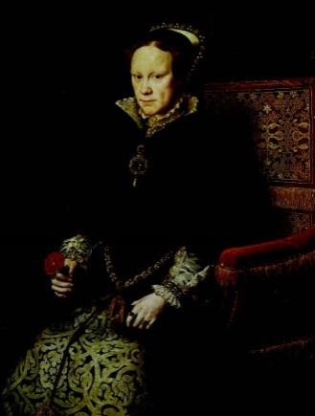  Mary I  1516 - 1558  Reigned: 1553 - 1558 |  | Mary I was the first female monarch to rule England in her own right.  The daughter of Henry VIII and Katherine of Aragon, Mary’s life was radically altered when her father divorced Katherine. Soon afterwards an Act of Parliament declared her illegitimate and removed her from the line of succession.  Although pressurised into giving up Mass and acknowledging the English Protestant Church, Mary remained loyal to Catholicism and refused to recognise her father as Head of the Church.  When her brother Edward died in 1553, Mary used the opportunity to reassert her claim to the throne by seizing it from Lady Jane Grey.  Mary’s priority as Queen was to restore Catholicism to England by reintroducing Roman Catholic bishops and reviving old heresy laws to ensure complete conversion of her subjects.  As a result around 300 Protestant heretics were burnt in three years, earning Mary the title of ‘Bloody Mary’.  Mary’s decision to marry Philip, King of Spain in 1554 proved very unpopular and she died four years later, childless. Mary was succeeded by her half-sister Elizabeth and her hopes for a Catholic England were never fully realised.
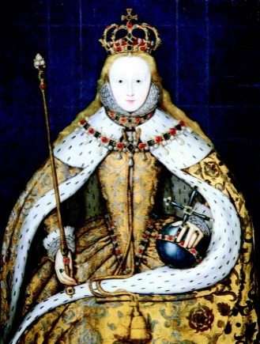  Elizabeth I  1533 - 1603  Reigned: 1558 - 1603 |  | Elizabeth was born in 1533, the daughter of Henry VIII and his second wife, Anne Boleyn.  When Elizabeth was just two years old her mother was beheaded for adultery on the orders of the king and Elizabeth was exiled from court. Her chances of succeeding the throne were further diminished by the birth of her half-brother Edward in 1537.  In 1553 Elizabeth’s elder half-sister, the Catholic Mary Tudor became queen. Elizabeth was viewed by Mary as a direct threat to her throne and was briefly imprisoned in the Tower of London in 1554, for her alleged involvement in a failed Protestant rebellion.  In November 1558, Elizabeth succeeded Mary to the throne and made religious reform her priority. The new queen recognised the importance of establishing a clear religious framework and helped to create a Church of England that, although largely Protestant, allowed some of the old Catholic traditions to continue. Despite pursuing a policy of moderation, many of her subjects were upset by this uneasy compromise and paid for their disloyalty with their lives.  Overall, Elizabeth’s reign is considered one of triumph and success and is often referred to as a ‘Golden Age’ of English history.

