Tudor Prisoners at the Tower
The Tower of London is a notorious prison, but it wasn’t built as one!
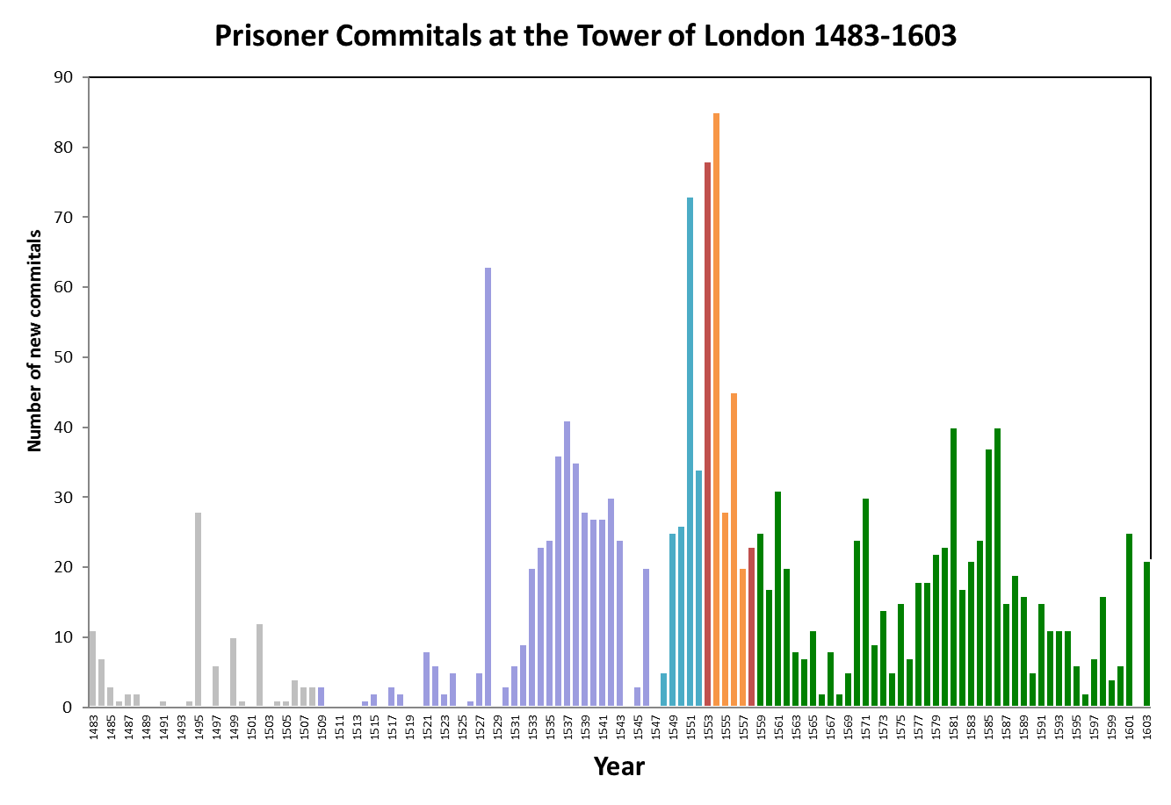
Use the graph to explore how frequently the Tower of London was used as a prison during the reign of each Tudor monarch. Why do you think there are spikes at different points on the graph?

