School Resource

Elizabethan Religious Upheaval

Key Characters

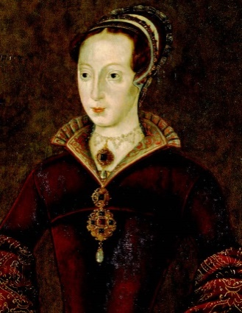  Lady Jane Grey  1537-1554  Reigned: 1553 |  | Lady Jane Grey ruled as Queen of England for just nine days in 1553 as part of an unsuccessful bid to prevent the accession of Mary Tudor.  As great granddaughter to Henry VII, Jane entered Katheryn Parr’s household at the age of 10 where she was exposed to a strongly Protestant and academic environment.  When Edward died in July 1553 Jane assumed the throne. After a few days, with overwhelming popular support, Mary Tudor made a triumphal entry into London and Jane was persuaded to relinquish the crown.  Mary imprisoned Jane, her husband and her father in the Tower of London where she was held in No 5 Tower Green and allowed to walk freely ‘at convenient times’ at the discretion of the Lieutenant of the Tower. Records suggest that Mary was anxious to spare Jane’s life but her failure to convert to Catholicism led to her execution for high treason in February 1554.
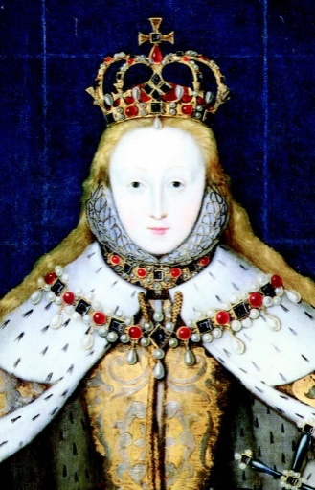  Elizabeth I  1533 – 1603  Reigned: 1558 - 1603 |  | Elizabeth was born in 1533, the daughter of Henry VIII and his second wife, Anne Boleyn.  When Elizabeth was just 2 years old, her mother was beheaded for adultery on the orders of the king and she was exiled from court. Her chances of succeeding the throne were further diminished by the birth of her half-brother Edward in 1537.  In 1553 Elizabeth’s elder sister, the Catholic Mary Tudor became queen. Elizabeth was viewed by Mary as a direct threat to her throne and was briefly imprisoned in the Tower of London in 1554, for her alleged involvement in a failed Protestant rebellion led by Thomas Wyatt.  In November 1558, Elizabeth succeeded Mary to the throne and made religious reform her priority. The new queen recognised the importance of establishing a clear religious framework and helped to create a Church of England that, although largely Protestant, allowed some of the old Catholic traditions to continue. Despite pursuing a policy of moderation, many of her subjects were upset by this uneasy compromise and paid for their disloyalty with their lives.  Overall, Elizabeth’s reign is considered one of triumph and success and is often referred to as a ‘Golden Age’ of English history.
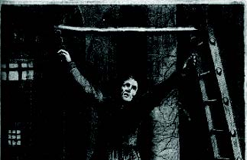  John Gerard  1564 - 1637 |  | John Gerard was a Jesuit priest imprisoned in the Salt Tower at the Tower of London in April 1587.  His failure to cooperate with officials led to a warrant being issued that sanctioned the use of torture. Gerard was tortured on three separate occasions but never revealed the names of his co-conspirators who were suspected of plotting to overthrow the queen.  Whilst residing at the Tower he corresponded with a number of people sympathetic to his cause, sending seemingly harmless messages with secret information written in invisible ink made from orange juice.  Together with fellow prisoner, John Arden, Gerard masterminded his escape. Little is known of John Arden other than the fact that he was listed in the prison records in 1594 as a condemned man.  On 5 October 1597, Gerard and Arden said Mass together in the Cradle Tower before swinging across the moat on a rope and onto a waiting boat. The jailer who assisted the pair with their escape also fled the Tower.  John Gerard later went on to write an account of his incarceration and escape from the Tower.
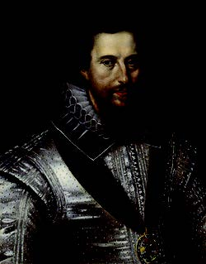  Robert Devereux  1566 - 1601 |  | Robert Devereux was a courtier and soldier, famous for his charm and his position as a royal favourite in the court of Elizabeth I.  Robert inherited the title Earl of Essex from his father and arrived at Elizabeth’s court in his twenties. Tall and handsome the queen warmed to him and, despite a tempestuous relationship, granted him numerous lucrative offices and appointments.  Despite his charms, Robert was vain, easily offended and disliked being ruled by a woman. In 1599 he was appointed Lord Lieutenant of Ireland and sent overseas to suppress an uprising. He failed and returned to England to try to explain his conduct to the queen. Rather than forgiving him, Elizabeth deprived Essex of his offices and had him placed under house arrest.  Enraged by the punishment, Essex plotted to raise the people of London in revolt against the queen and government, and seize control. When his campaign failed Robert Devereux was arrested and imprisoned and put on trial for treason at the Tower of London.  He was found guilty and executed on 25 February 1601.

