Applying History:
Tower of London

Artefacts

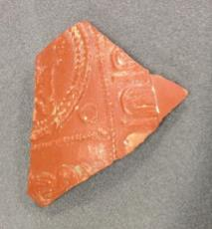  Samian fragment  Date: 150 – 200AD  Found: Inner Ward excavation  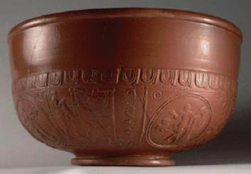  A whole example of this type of samian ware bowl. |  | This is from a high-status Roman bowl used for displaying and serving food. It was found during an excavation in the Inner Ward of the Tower, close to the modern Raven shop. The Tower of London holds some very significant Roman archaeology. A Roman road and houses have been found deep underneath the Inner Ward, and the White Tower was only located here to take advantage of the defensive walls that once marked the edge of the Roman City.  The bowl is made of samian; a type of pottery that was mass-produced in Roman Gaul (modern-day France). The external pattern was formed by pressing clay into a decorated mould, and the inside was made smooth using a potter’s wheel. The clay was left to dry, causing it to shrink away from the side of the mould and make it easy to remove. Before firing, it was covered in slip (clay mixed with water) to give it a distinctive colour and shine.  The pattern has been squashed on the outside; there are even some fingerprints showing that it wasn’t dry when it was removed from the mould. This rushed manufacture suggests that it was made in Southern France in the late 2nd century AD, making it 1,850 years old.
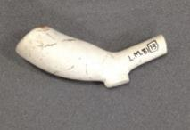  Clay pipe  Date: 1680 – 1710  Found: Legge’s Mount excavation  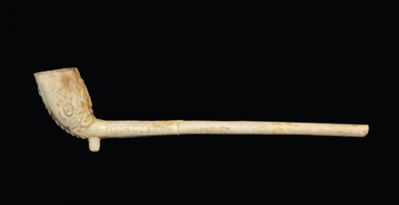  An example of a complete clay pipe with a decorated bowl. |  | This is a clay pipe, used for smoking tobacco more than 300 years ago. Clay pipes were first made in Elizabethan England after the introduction of tobacco. At first, tobacco was extremely rare and expensive, so the pipes were very small, but as imports increased, the pipes got bigger. Their design was also very susceptible to changing fashions, so we can work out when they date from quite accurately from their size and shape. This pipe dates from 1680-1710.  Although this pipe was manufactured in London, it was made from a particular kind of white clay, kaolin, that was mined in Cornwall and brought to London by boat. Pipes were formed in moulds and fired in small kilns.  The inked mark ‘L.M.81[13]’ on the side is a code written by the archaeologist to show that it was excavated from Legge’s Mount at the Tower of London in 1981. Legge’s Mount is a bastion tower on the outer wall, originally built in 1275-1285. By Tudor times, the Mint was located near here, and in 1696 Legge’s Mount was handed over to the Mint when Isaac Newton took over as Warden of the Mint. This pipe may well have been smoked by one of Newton’s contemporaries.
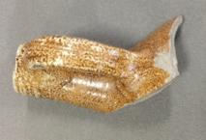  Bellarmine fragment  Date: 1550 - 1700  Found: Tower of London  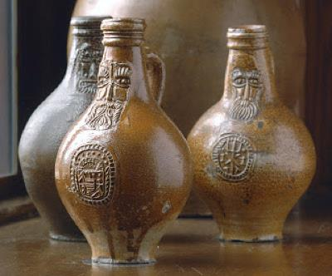  Examples of complete bartman jugs |  | This is the neck and handle of a Bartman jug – made in Germany in the 16th or 17th century. Our name for them is a corruption of the German name ‘Baardman’, or beard man, because on the neck, opposite the handle, there was the carved face of a man with a large beard. People thought the bearded face looked like Cardinal Bellarmine (who confronted Galileo in the early 17th century over the theory that the earth  turned around the sun), so they are often called ‘Bellarmine’ jugs.  Bartman jugs were for storing and drinking wine and beer. They are made of a type of pottery called stoneware which has been fired so hot (1200-1400°C) that the minerals fuse together, making the pottery waterproof and suitable for storing liquids. England imported huge quantities of German stoneware, especially Bartman jugs, until the mid-17th century  when we developed our own stoneware industry and, more importantly, developed glass bottles as an alternative.  The speckled surface is from a salt glaze. At the end of the firing, salt was thrown into the kiln which instantly vapourised and fused with the surface of the pottery. Chlorine gas was given off; a poisonous gas that was later used as chemical weapon in the First World War.
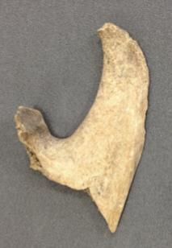  Cattle jaw  Date: unknown  Found: Legge’s Mount excavation |  | This is part of a cow’s jaw bone, excavated from an archaeological site at the Tower of London. This is the back edge of the jaw, from where it rotates against the skull. You can see that there are very clear cut marks on the bone. These are from a knife, and from a butcher making sure that no piece of meat went to waste. We are used to large cuts of meat, such as steaks or maybe a shoulder of lamb, but no part of an animal would (or should) have gone to waste. This might have become a piece of braised ox cheek.  Before lorries existed to transport our food, the country was covered in droveways; roads that farmers would use to make their livestock walk to market. In London, the cows from Kent and Sussex would be walked to Southwark and Bermondsey, just south of London Bridge. They would be butchered here and then traded across the capital, including to the Tower of London.
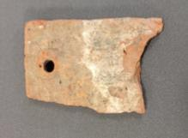  Peg tile  Date: medieval or later  Found: Coldharbour excavation  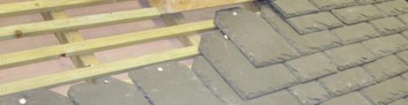  A modern roof using peg tiles |  | This is a roof tile made of fired clay. It is known as a peg tile because it would have been hung from a roof with little wooden pegs through the holes. Unlike many archaeological finds that can be dated by changing fashions, roof tiles are almost totally functional and change little over the centuries, so a reliable date cannot be put forward for this object.  Tiles were made in a similar way to bricks. A flat surface would be covered with sand so that the clay did not stick. A shallow wooden frame would then be laid flat, and clay pushed into the mould. The spare clay sticking up above the mould would be sliced off with a wire, leaving two contrasting sides that indicate how each was formed.  Different areas have different traditions for building techniques depending on the materials that are available locally. Much of the country in medieval times would have had thatched roofs, including London, until a large fire in 1212 resulted in decree banning the use of thatch. Luckily, London is well supplied with clay so was able to make the transition to tiled roofs quite easily. This tile was found at the Tower of London, but it is typical of tiles across London throughout medieval and post-medieval history.
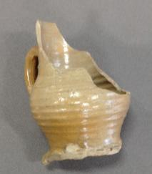  Beer mug  Date: c.1480 - 1550  Found: Tower moat excavation  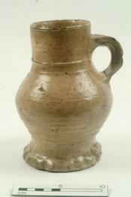  A raeren mug  Image courtesy of the Museum of London |  | This is a 500 year old beer mug. It was found in 1995 in an archaeological excavation of the moat at the Tower of London, but it was made close to the border of Belgium and Germany in an area called Raeren.  Raeren was famous for this type of pottery from the late 15th to 16th century, and it exported huge quantities of it across Europe. The mug was made on a potter’s wheel and it has a very characteristic shape. The wavy edge around the base was made by pinching the clay - you can still see the scratches from the potter’s thumb nail. It is made of stoneware which has been fired to such a heat that it becomes waterproof.
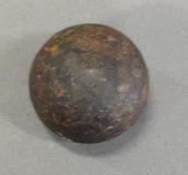  Cannonball  Date: 1600s  Found: Tower moat excavation |  | This is a cast iron cannon ball, found in the moat at the Tower of London; a very clear sign of the defensive and military history of the Tower. It was probably even fired from the battlements. Gunpowder, for firing cannons, was being stored  at the Tower by 1338, and in 1345 we have records of there being 100 cannon held here. These early cannon, however, were firing stone shot. It is not until the 16th century that cast iron was used.  This cannonball may feel heavy, but it is a very small example, weighing under 3 3/4 lbs (1.25kg). It does not fit any of the standard weights as set out by the Board of Ordnance (based at the Tower) in 1716, so it most likely dates from the 17th century and is more in keeping with the lighter artillery seen during the Civil War period. A full cannon fired shot weighing 42lb, but these were discontinued by the 18th century for their unwieldiness. A cannon of that size would be immensely destructive of defensive walls, but the smaller sized shot seen here would have been used against attacking forces, to disabling and deadly affect.
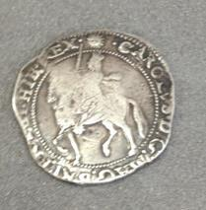  Charles I halfcrown  Date: 1645 - 1646  Found: Tower mint under Parliament |  | During the Civil War, the armies of Parliament and Charles I fought each other for control of the country.  The Tower of London was captured by Parliamentary forces in 1642 but Parliament continued to make coins bearing Charles’ image until his execution in 1649.  How do we know this coin was made by Parliament? There is a small sun at 12 o’clock above the king’s head which is called a mint mark, and like a hallmark was used to make sure the men who made the coins could be held accountable if any were found to be too light or of poor silver quality.
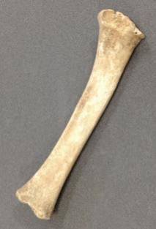  Animal bone  Date: 1600s  Found: Legges Mount excavation |  | This is a bone from a young sheep or goat. It is called the radius, which is the front leg of four-legged animal - the equivalent of a human forearm. It is possible to tell that it’s from a young animal not by the size, but because if it was an adult, there would be a small bone fused to one end of this one. We have the same basic skeleton, and the same joint  in our wrists that fuses at 16 - 22 years old. Animal and human skeletons keep growing and changing throughout our lives - think of milk teeth, adult teeth and wisdom teeth. These changes help archaeologists in their work studying animal and human remains, but it is also vital knowledge in forensic work to be able to work out the age of a skeleton.  This bone was found in an excavation at the Tower of London and dates from the 17th century. It does not appear to have any butchery marks, but it almost certainly arrived at the Tower as meat; lamb. Before lorries existed to transport our food, the country was covered in droveways; roads that farmers would use to make their livestock walk to market. In London, the sheep from Kent and Sussex would be walked to Southwark and Bermondsey, just south of London Bridge. They would be butchered here and then traded across the capital, including to the Tower of London.
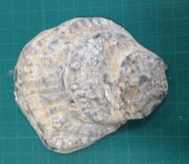  Oyster shell  Date: unknown  Found: Tower foreshore |  | This is an oyster shell that was found at the Tower of London. Oysters were consumed in vast quantities throughout the medieval period and up to Victorian times; by rich and poor alike. Oysters are therefore a very common find in archaeological excavations, especially in rubbish pits.  Oysters thrive in tidal water, so the Thames Estuary was always a rich source, and industry also developed around oyster farming. But the Industrial Revolution brought pollution and over-fishing, and there was a sudden collapse in the numbers available. Harder to get hold of, the oyster then became the luxury food item that is familiar today.
Peg tile  Date: medieval or later  Found: Coldharbour excavation  A modern roof using peg tiles. |  | This is a roof tile made of fired clay. It is known as a peg tile because it would have been hung from a roof with little wooden pegs through the holes. Unlike many archaeological finds that can be dated by changing fashions, roof tiles are almost totally functional and change little over the centuries, so a reliable date cannot be put forward for this object.  Tiles were made in a similar way to bricks. A flat surface would be covered with sand so that the clay did not stick. A shallow wooden frame would then be laid flat, and clay pushed into the mould. The spare clay sticking up above the mould would be sliced off with a wire, leaving two contrasting sides that indicate how each was formed.  Different areas have different traditions for building techniques depending on the materials that are available locally. Much of the country in medieval times would have had thatched roofs, including London, until a large fire in 1212 resulted in decree banning the use of thatch. Luckily, London is well supplied with clay so was able to make the transition to tiled roofs quite easily. This tile was found at the Tower of London, but it is typical of tiles across London throughout medieval and post-medieval history.
Sandstone  Date: medieval or post medieval  Found: Tower of London excavation |  | This is a piece of building stone; geologically known as Lower Greensand. It was deposited between 140 - 100 million years ago, as layers of sand when the South of England was under the sea. Much of the Tower of London was built using Lower Greensand sourced from Kent, but this Kentish ‘rag’ stone does not generally contain fossils. The fossils in this piece of stone suggest that it is a closely related type of Greensand imported from Devon. The flat side of this stone has been worked very neatly by a stone mason using a chisel.
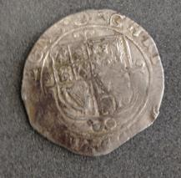  Charles I shilling  Date: 1641 - 1642  Found: Tower mint under Charles I |  | During the Civil War, the armies of Parliament and Charles I fought each other for control of the country.  The Tower of London was captured by Parliamentary forces in 1642 but Parliament continued to make coins bearing Charles’ image until his execution in 1649. This coin dates to when Charles still had the Tower under his authority.  How do we know this coin was made by Charles I? There is a small triangle in a circle symbol at 12 o’clock above the king’s head and top of the shield which is called a mint mark and like a hallmark was used to make sure the men who made the coins could be held accountable if any were found to be too light or of poor silver quality.

Archaeological symbols

Type | Description | Written
Site number | A number given to each excavation so we can trace where an artefact was found. | TOL 27
Context number | The layer in which an object was found.
Small find number | A small find is an artefact which was thought to be significant enough to be given its own number. Artefacts found in large numbers are stored together under one number as a ‘bulk’ find. | 